Kindergarten
4 - 24 Count Crayola Crayons
2- 12 count Ticonderoga Pencil
2 – Bottles of Elmers Glue
1 – Crayola Washable Markers
8 – Glue Sticks
2 – Kleenex
1 – Clorox Wipes
1 – 4 pack Dry Erase Markers
1 – Point End Fiskar Scissors
2 – Hand Sanitizer
1 – Box of 1 Quart Ziploc Bags
1 – Pack of Post it Notes
$5.00 for additional supplies during year

1st Grade
Fabric Zipper Pencil Pouch
12 #2 pencils sharpened
1 – Kids Fiskar Scissors
2 - Jumbo Elmer Glue Sticks
2 - Kleenex
4 - Dry Erase Markers
1 - Spiral Notebook, wide rule
2 - 24 ct. Crayola Crayons
1 box thin washable markers
2 sturdy Pocket Folders
1 – Post it Note pack
Clorox Wipe
Sturdy Personal Earphones
$3.00 for additional supplies
**Please take some time and label as many of y our child’s supplies as possible**

2nd Grade
24 #2 Pencils
1 – Pair of scissors
8 – Glue Sticks
2 - Kleenex
1 - 24 ct. Crayola Crayons
2 - boxes of Dry Erase Markers
1 - Clorox wipes or Hand Sanitizer
1 – Spiral Notebook
2 - Composition Notebooks
1 – Plastic folder with prongs
1 – Pair of head phone
1 – Student supply box
$3.00 for additional supplies

3rd Grade
24 #2 Pencils
1 Pencil sharpener with shavings catcher
Zipper pencil pouch
1 - Scissors
2 - Glue Sticks
1 pkg of Eraser Caps
1 – Standard Folder
1 – Sturdy take home folder
1 - box 24 ct. Crayola Crayons
2 - Spiral Notebooks, wide rule
1 – Composition Notebook
12” Ruler with CM
1 - box of dry erase markers
1 pair of headphones
Water Bottle
Wish List: Hand Sanitizer, Clorox Wipes, and 3 Kleenex boxes

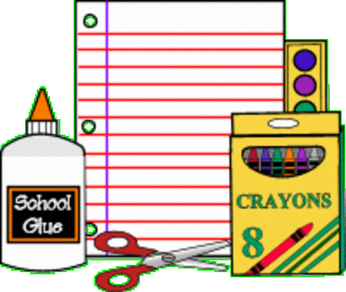

4th Grade
12 (or more) - #2 Pencils
(Dixon or Ticonderoga)
1 – Box markers, OR colored pencils, OR crayons
2 - Notebooks
1 – Box of Expo Dry Erase Markers
1 - Take Home Folder
2 – 1 inch 3 ring binder with a plastic outside cover
1 - Clorox wipes
1 – Box of Kleenex
1 – Pair of Headphones

5th Grade
1 – 5 subject notebook with pockets
12 - #2 pencils (no mechanical)
1 - Pack Dry Erase Marker
1 - Scissor
4 - Glue stick
4 - Kleenex
4 - Clorox wipes
1 – Pencil Box
1 – Pair of ear buds/Headphones

