Glenwood Elementary School

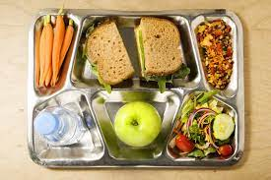

Lunch schedules are as follows:
Y5: 12:05pm-12:25pm

Kindergarten: 12:30pm-12:50pm

1st Grade: 11:40am-12:00pm

2nd Grade: 12:05pm-12:25pm

3rd Grade: 12:30pm-12:50pm

4th Grade: 12:05pm-12:25pm

5th Grade: 11:40am-12:00pm

