EAST KENTWOOD VARSITY GIRLS WATER POLO 2015

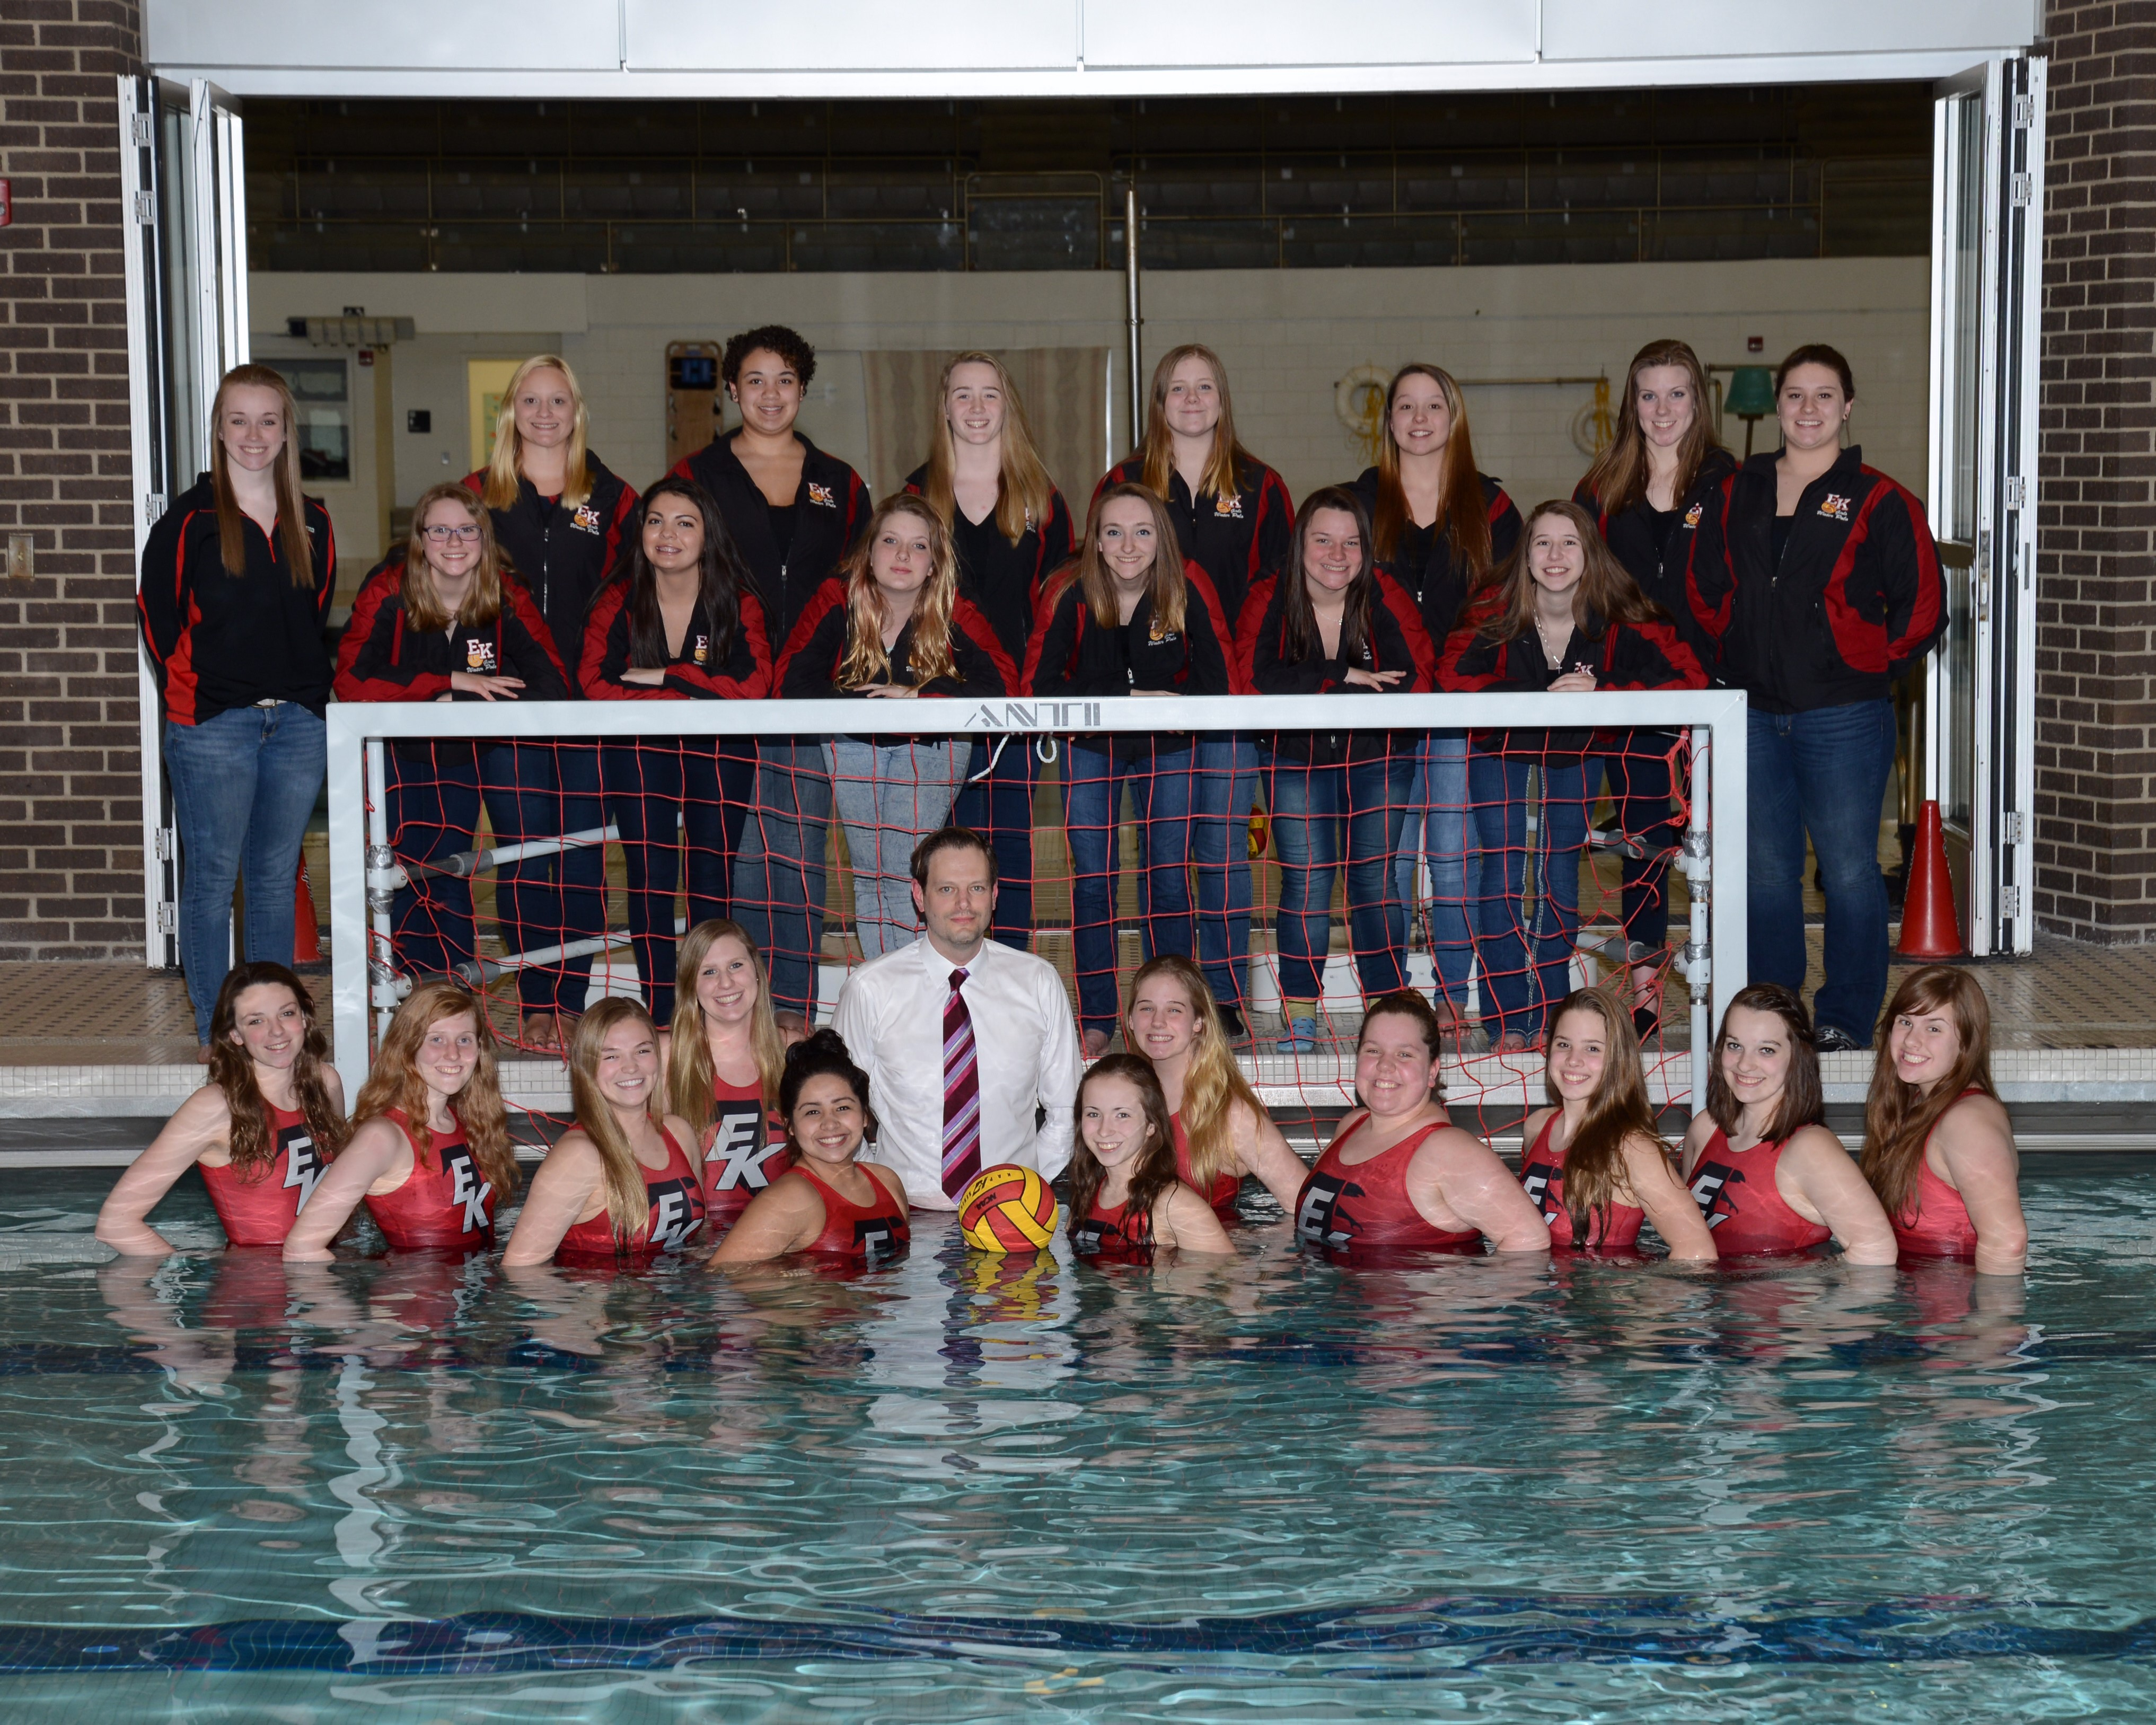
Click here for the schedule.

