East Kentwood Varsity Football 2014

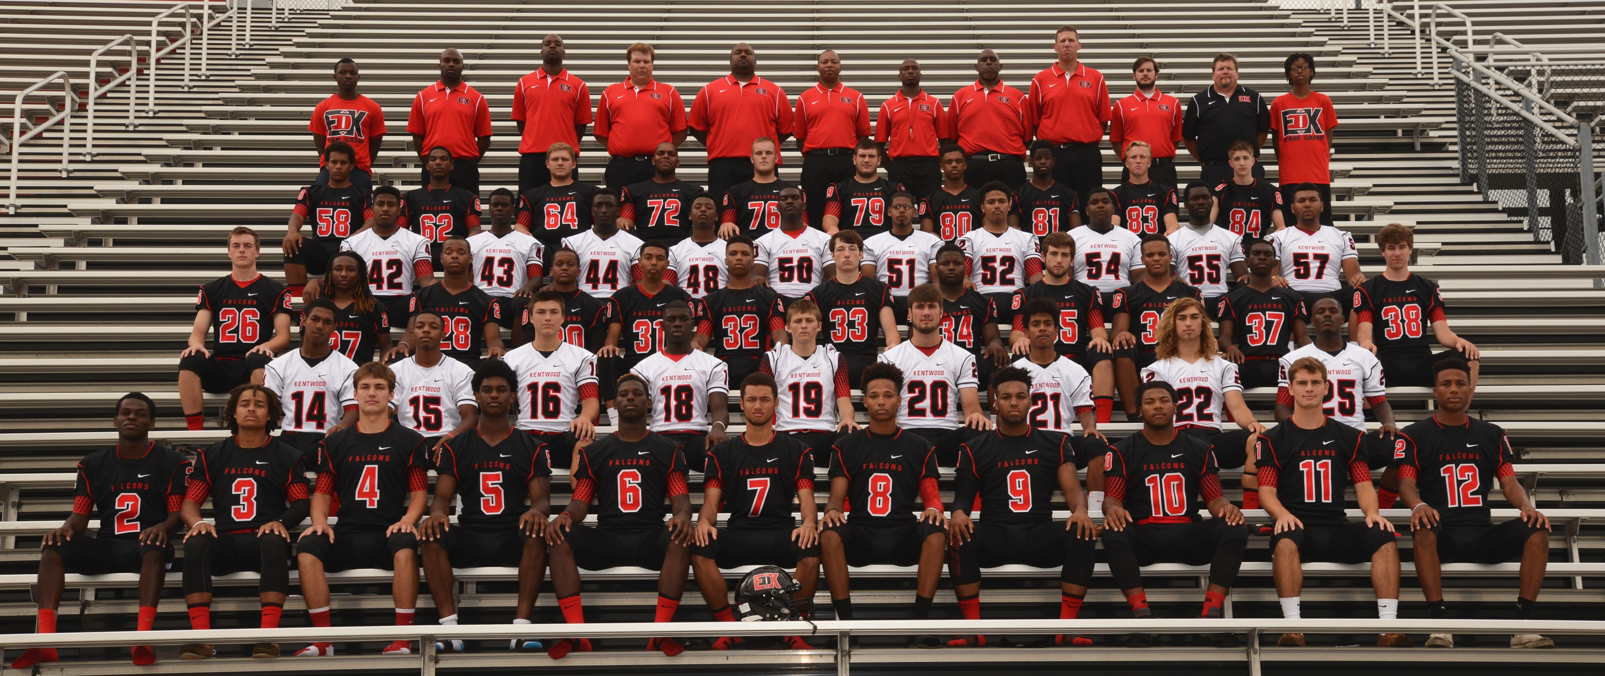

Click here for schedule

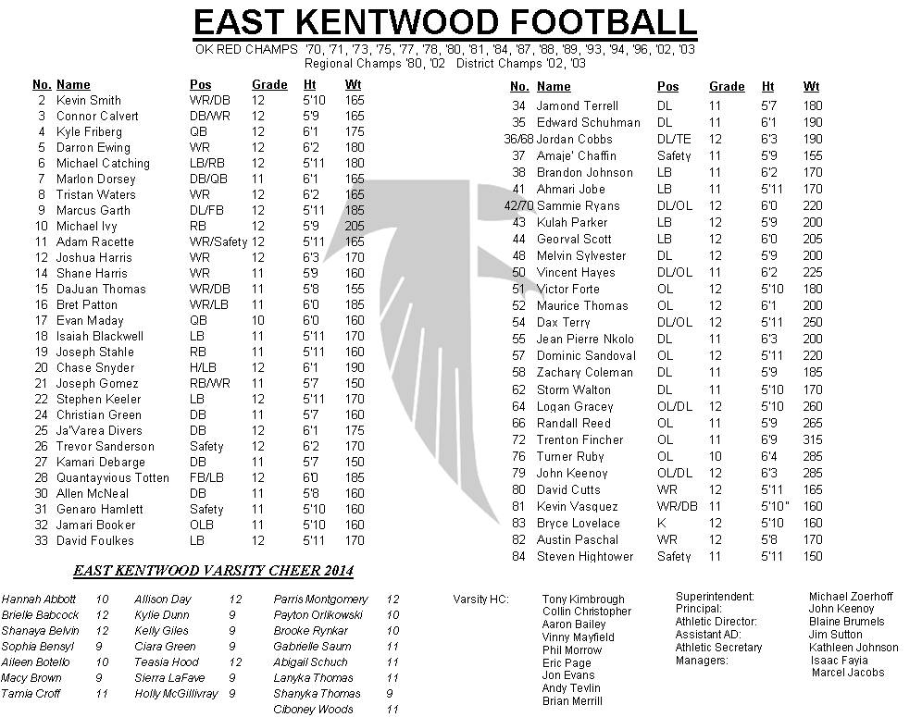

JV Football 2014

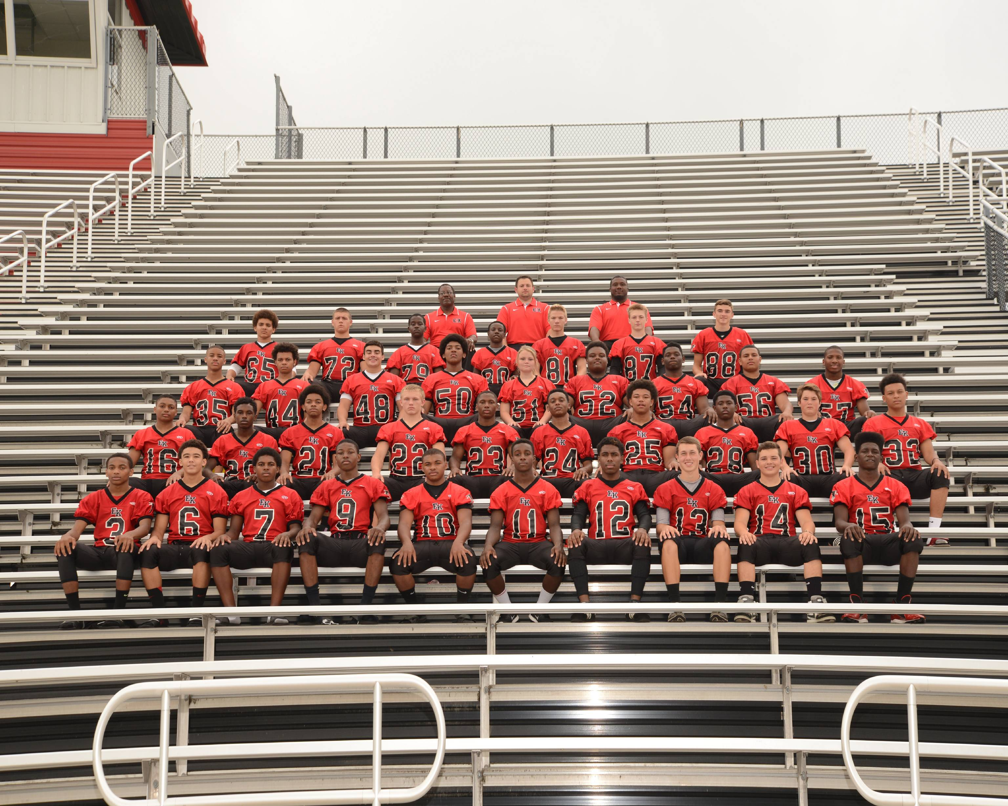

JV Coach: Marvin Lacey
Asst: Corey Alston
Asst: Colin Chelowich

Click here for schedule

EK Freshman Football 2014

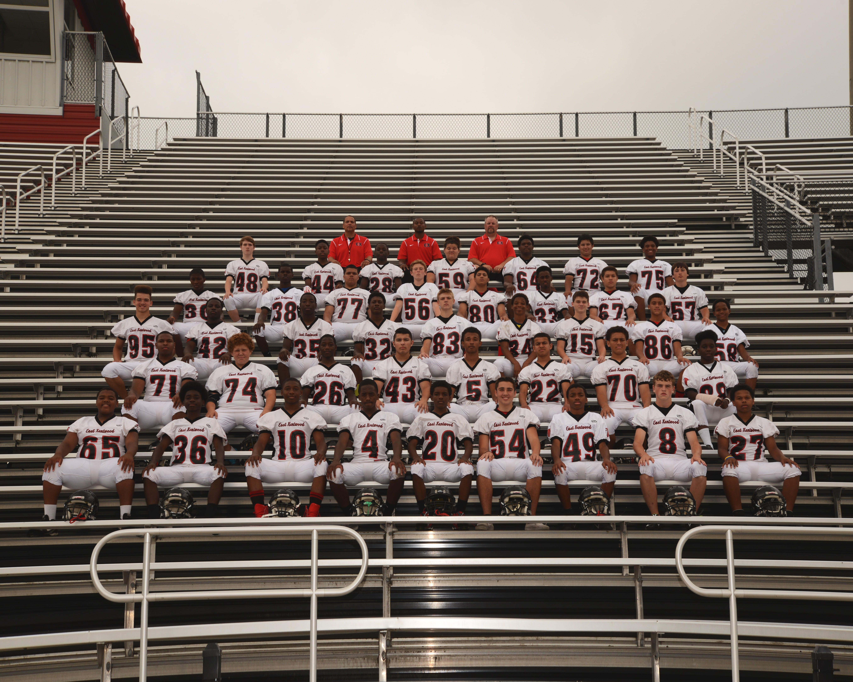

Freshman Coach: Kurt Schmidt
Asst: Brandon Kimble
Asst: David Thomas

Click here for schedule



