EAST KENTWOOD VARSITY BOYS TRACK AND FIELD 2016
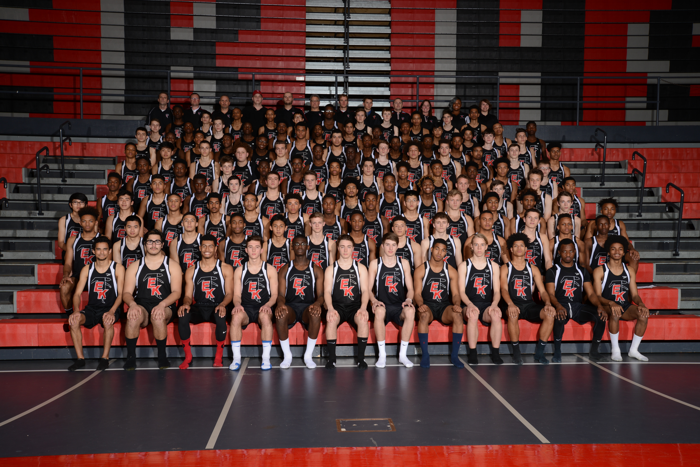
Click here for the schedule.

EAST KENTWOOD GIRLS TRACK AND FIELD 2016
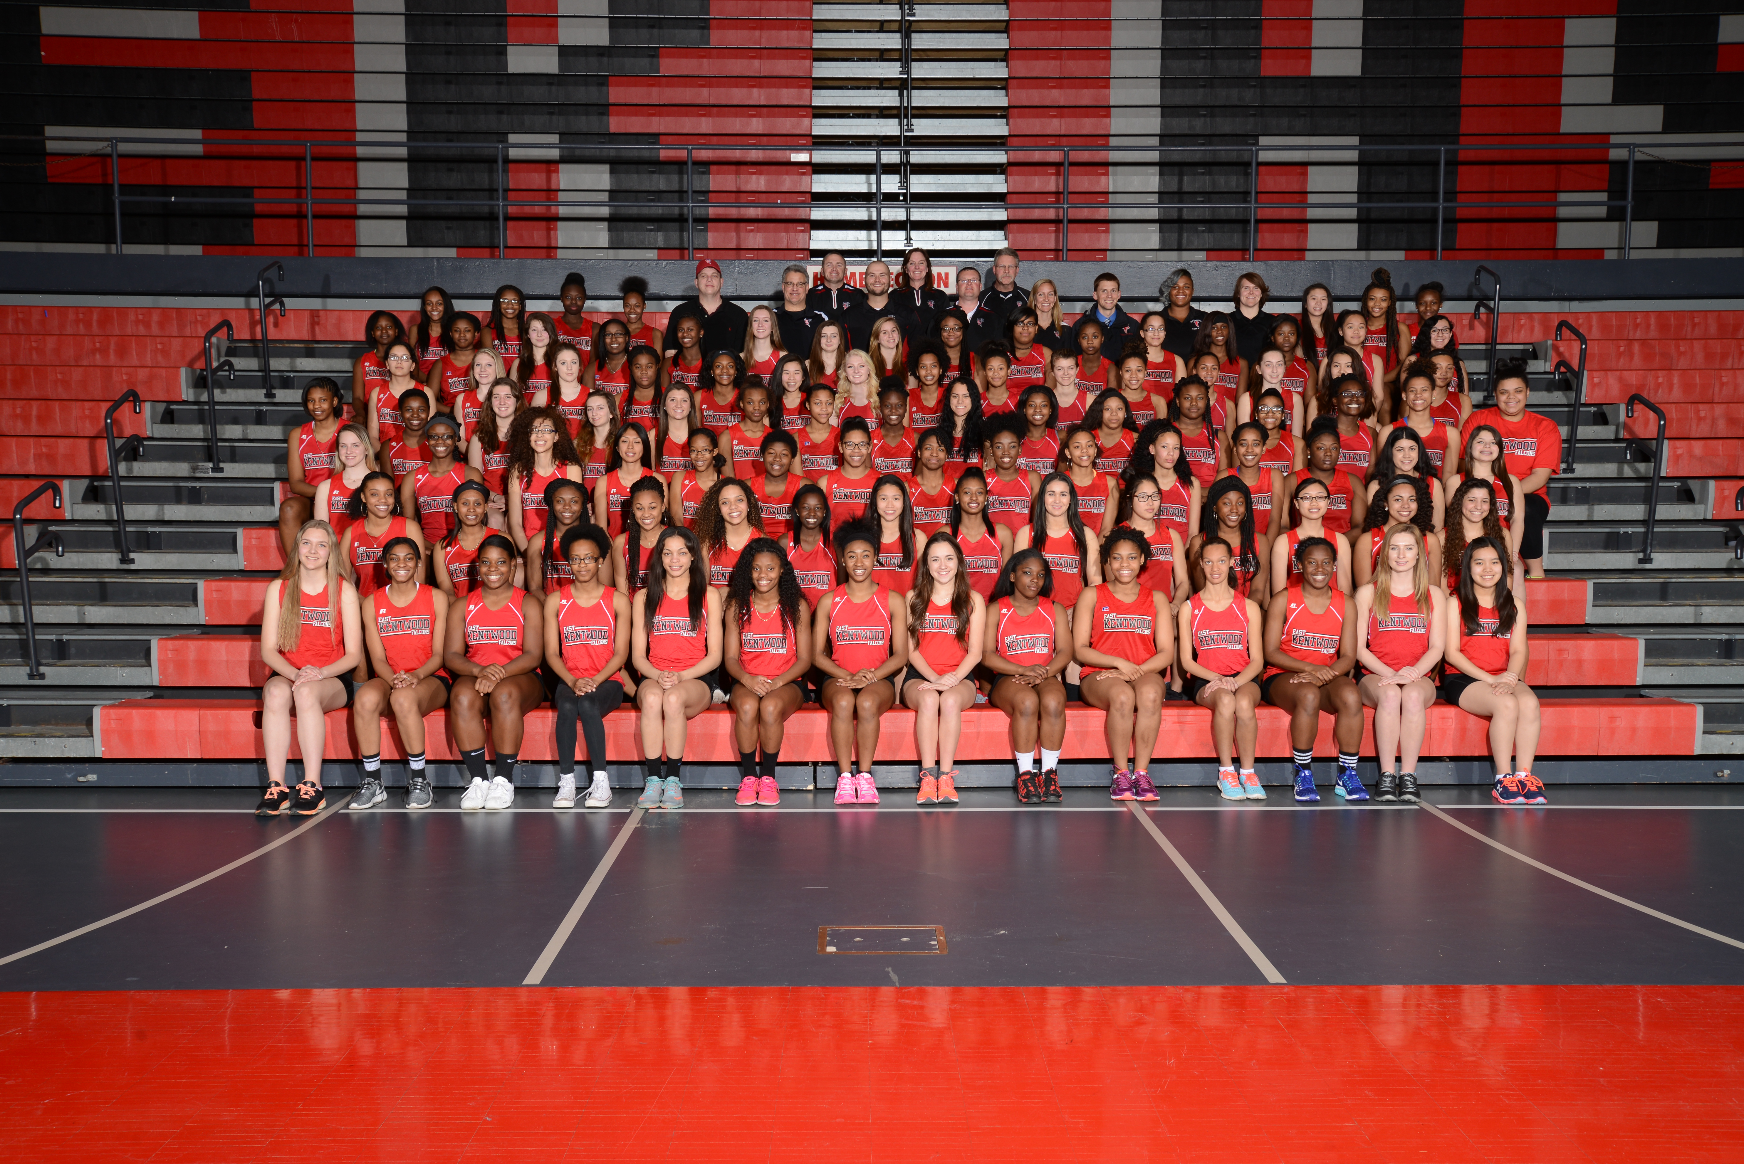
Click here for the schedule.

