EAST KENTWOOD VARSITY GIRLS SOCCER 2015
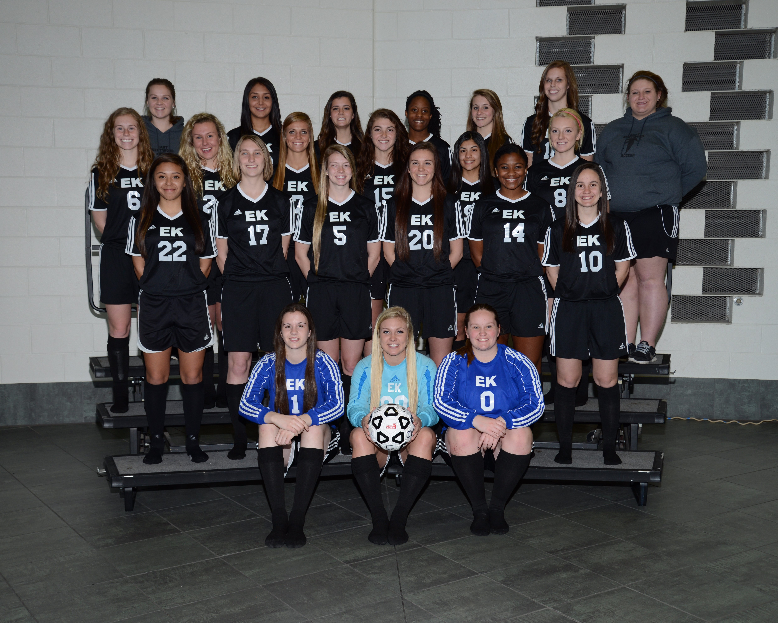
Click here for the schedule.
EAST KENTWOOD J.V. GIRLS SOCCER 2015
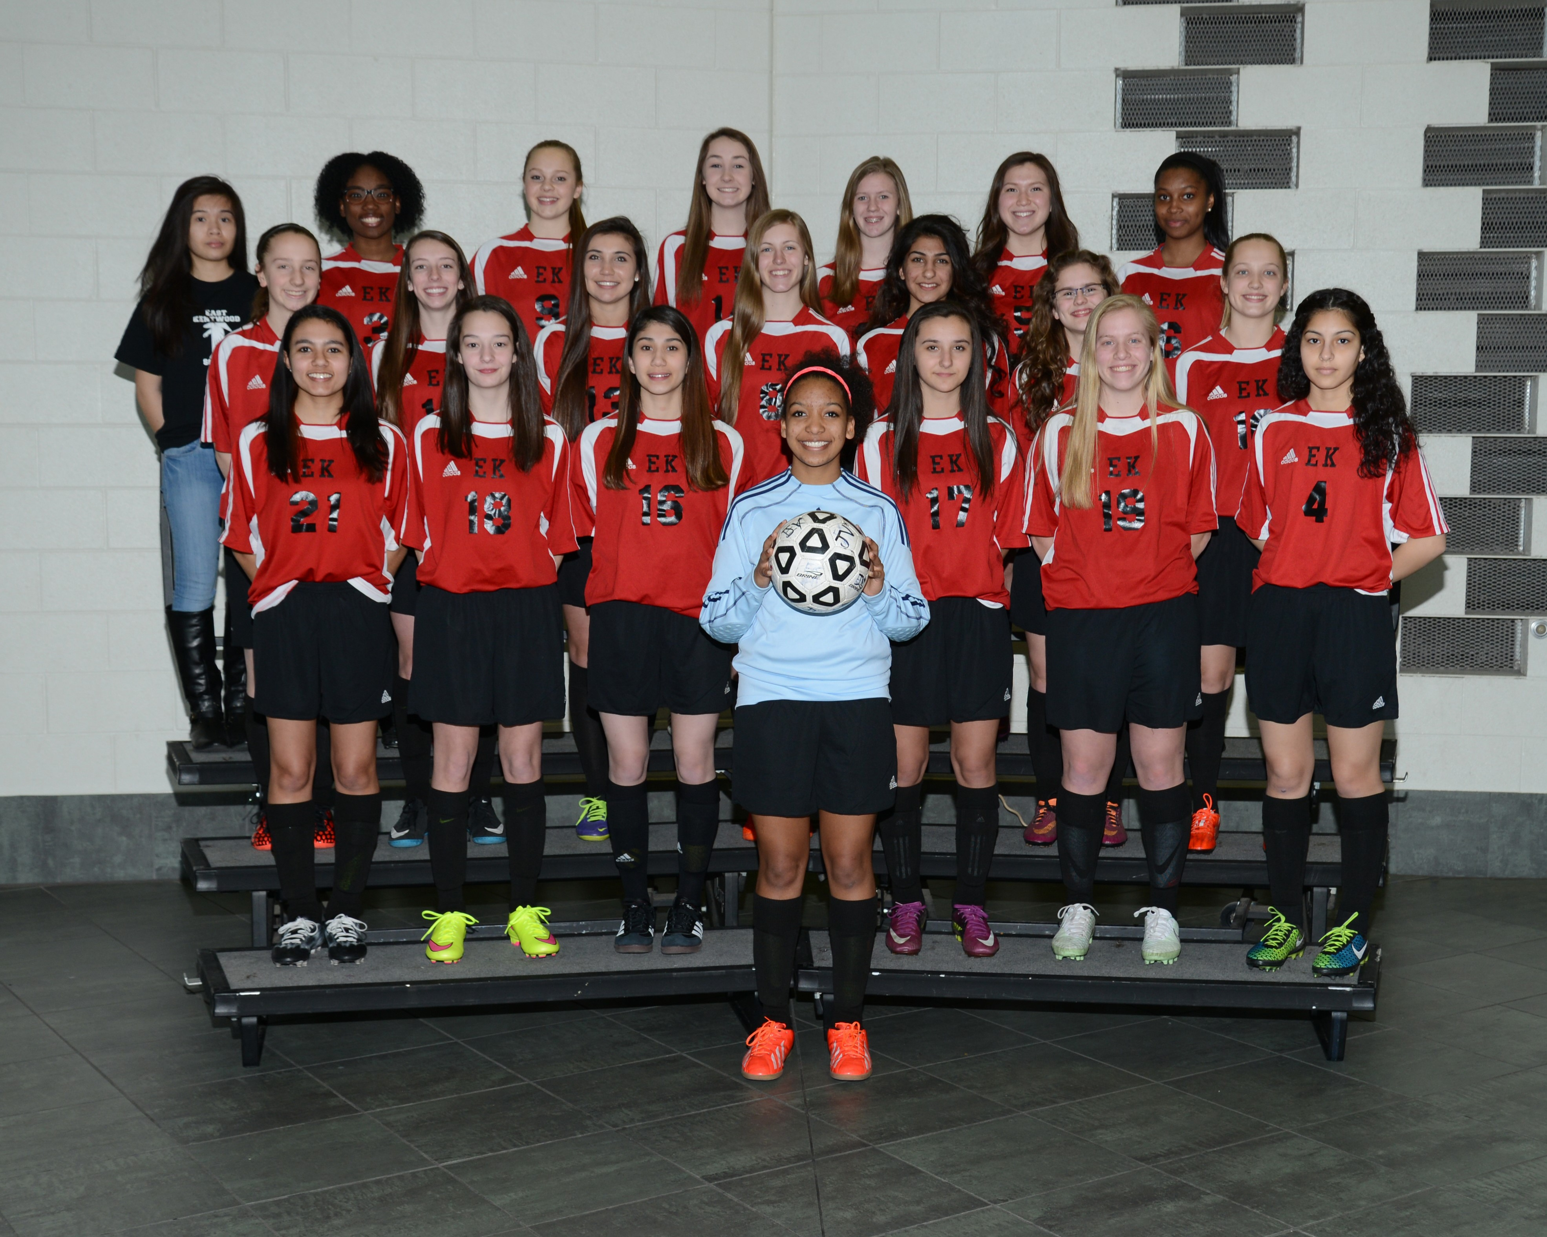
Click here for the schedule.
EAST KENTWOOD FRESHMAN GIRLS SOCCER 2015
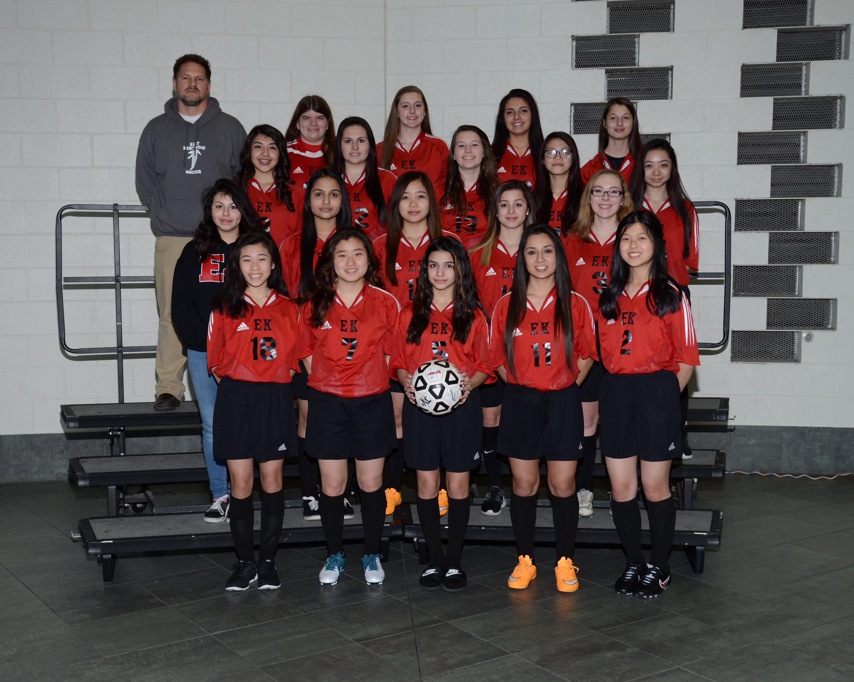
Click here for the schedule.

