EAST KENTWOOD VARSITY BOY’S BASKETBALL 2014-2015

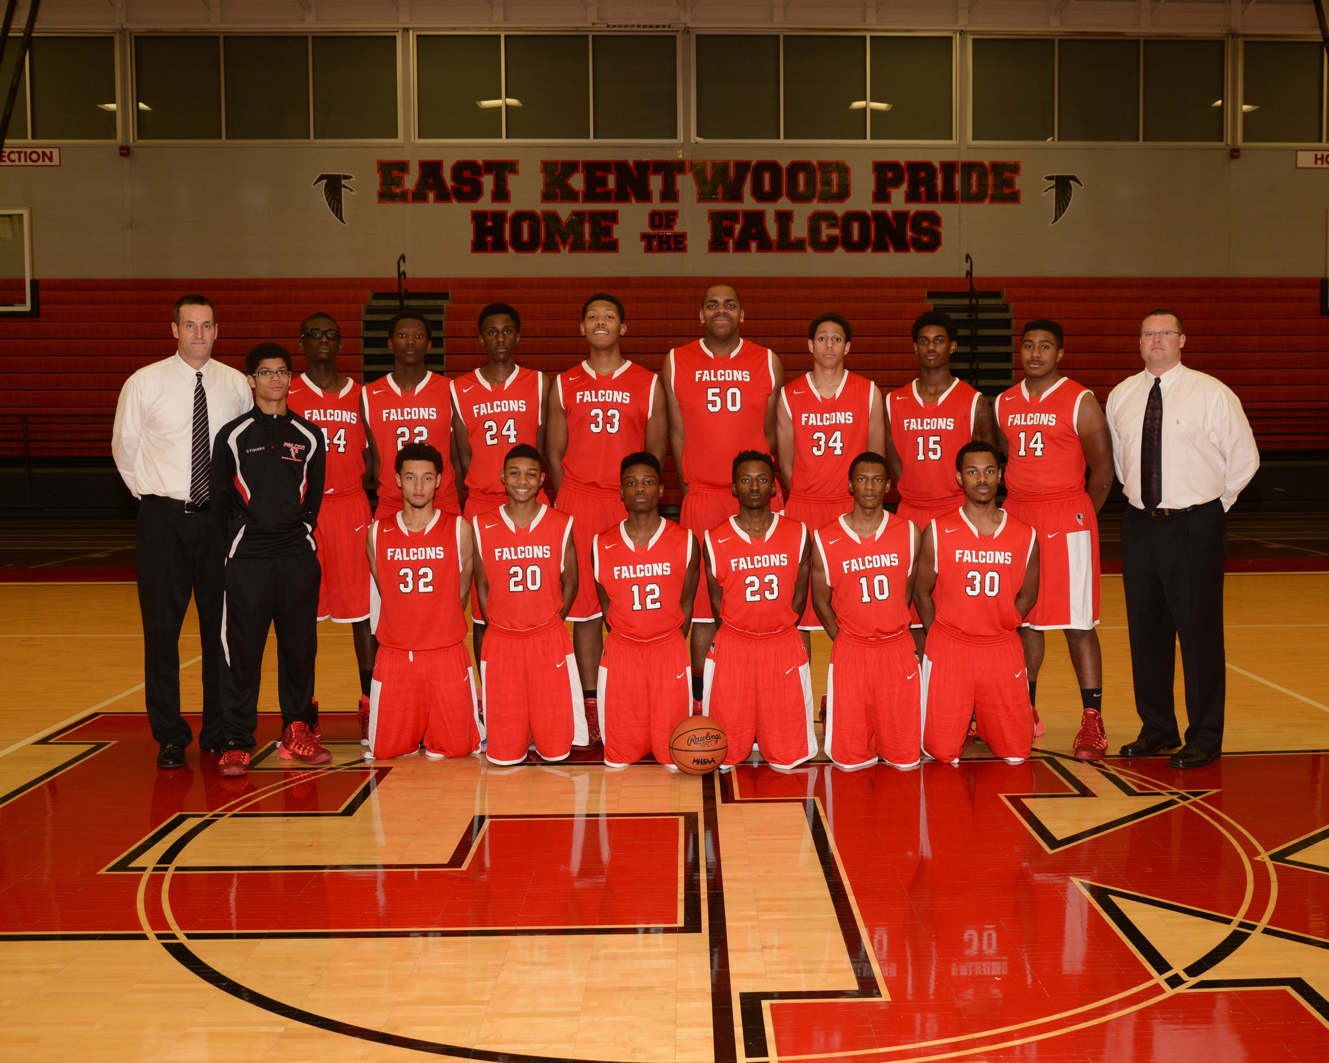

Click here for schedule

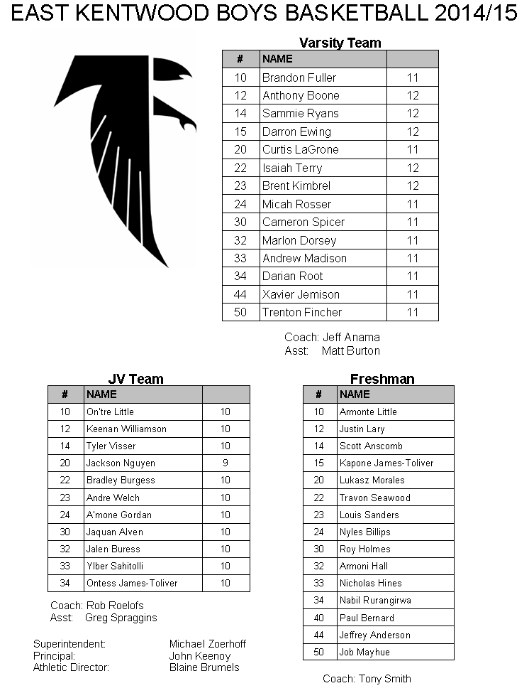

EAST KENTWOOD BOY’S JV BASKETBALL 2014-15

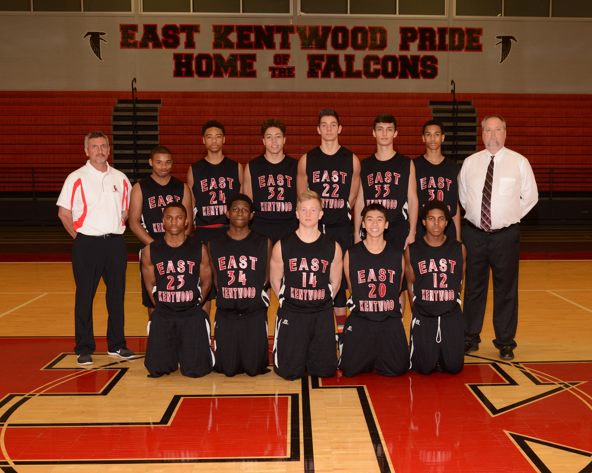

Click here for schedule

EAST KENTWOOD FRESHMAN BOY’S BASKETBALL 2014-15

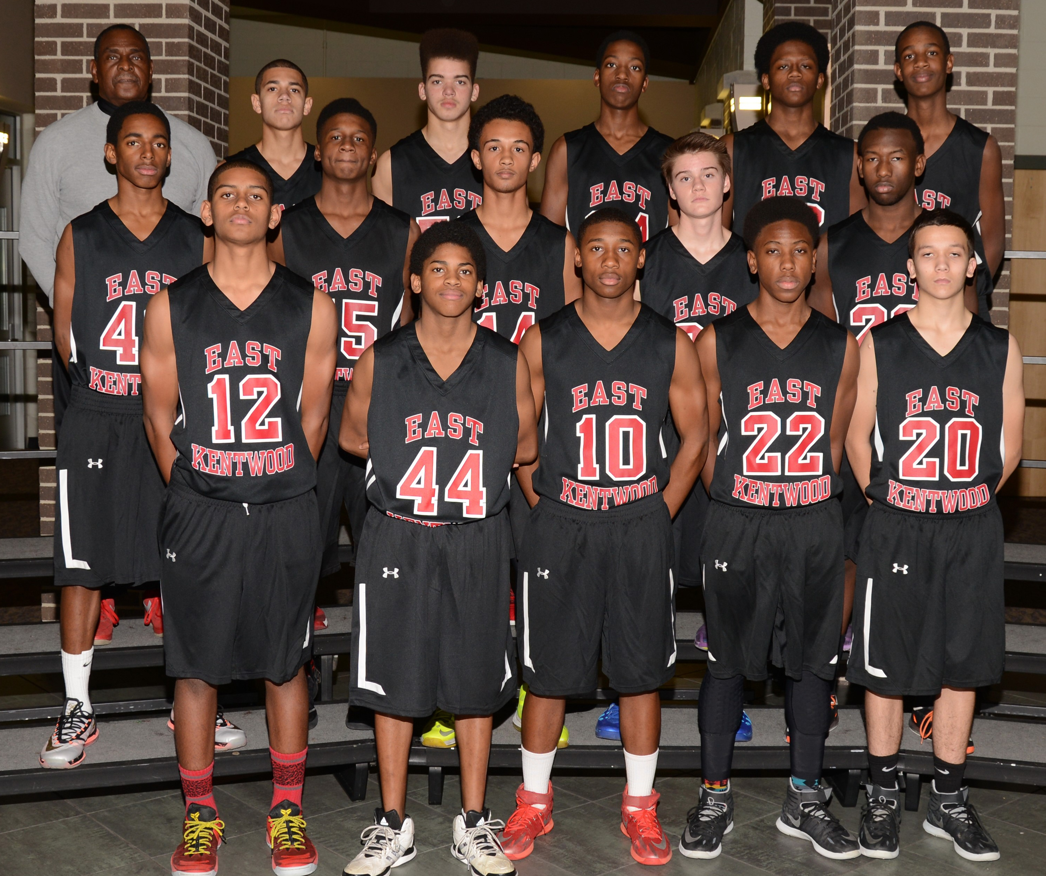

Click here for schedule

