EAST KENTWOOD GIRLS VARSITY GYMNASTICS 2015-16

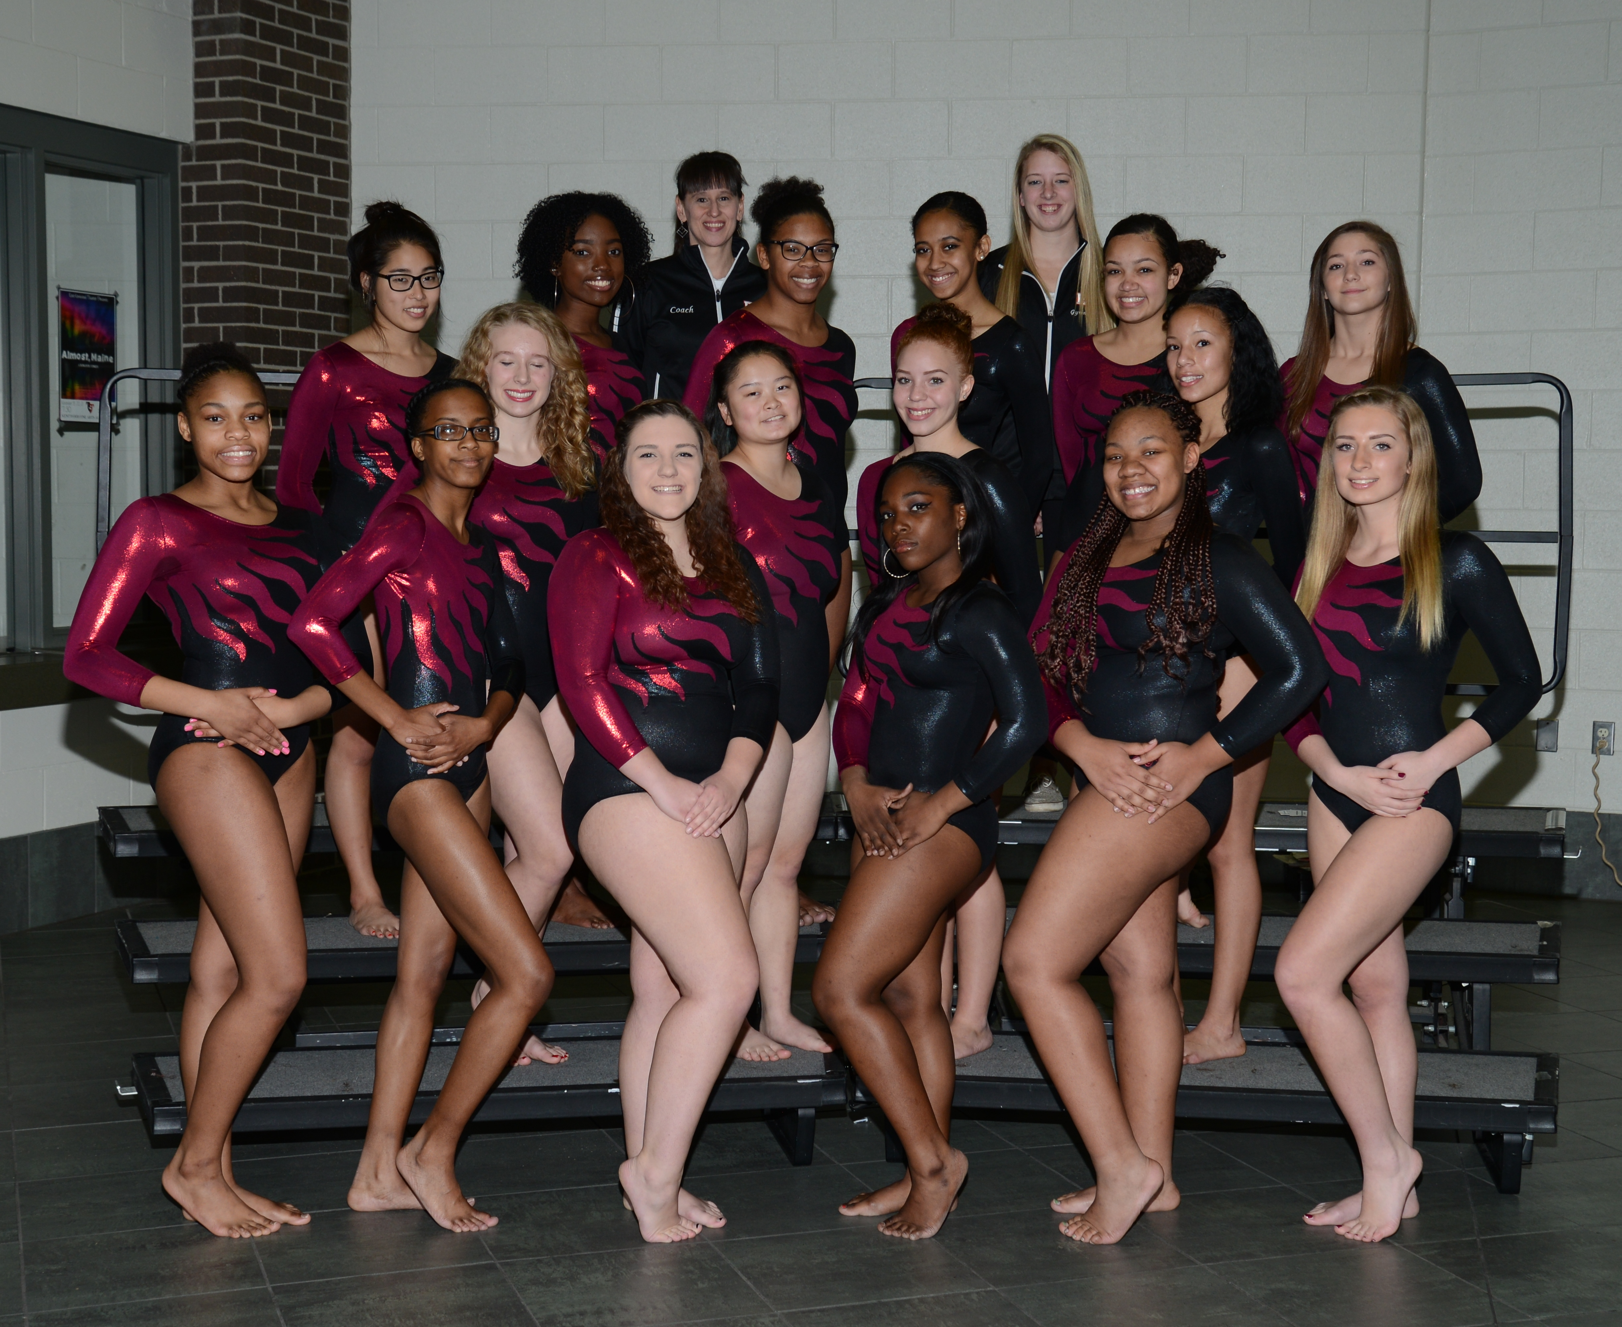

Click here for schedule

