EAST KENTWOOD VARSITY BOYS GOLF 2016
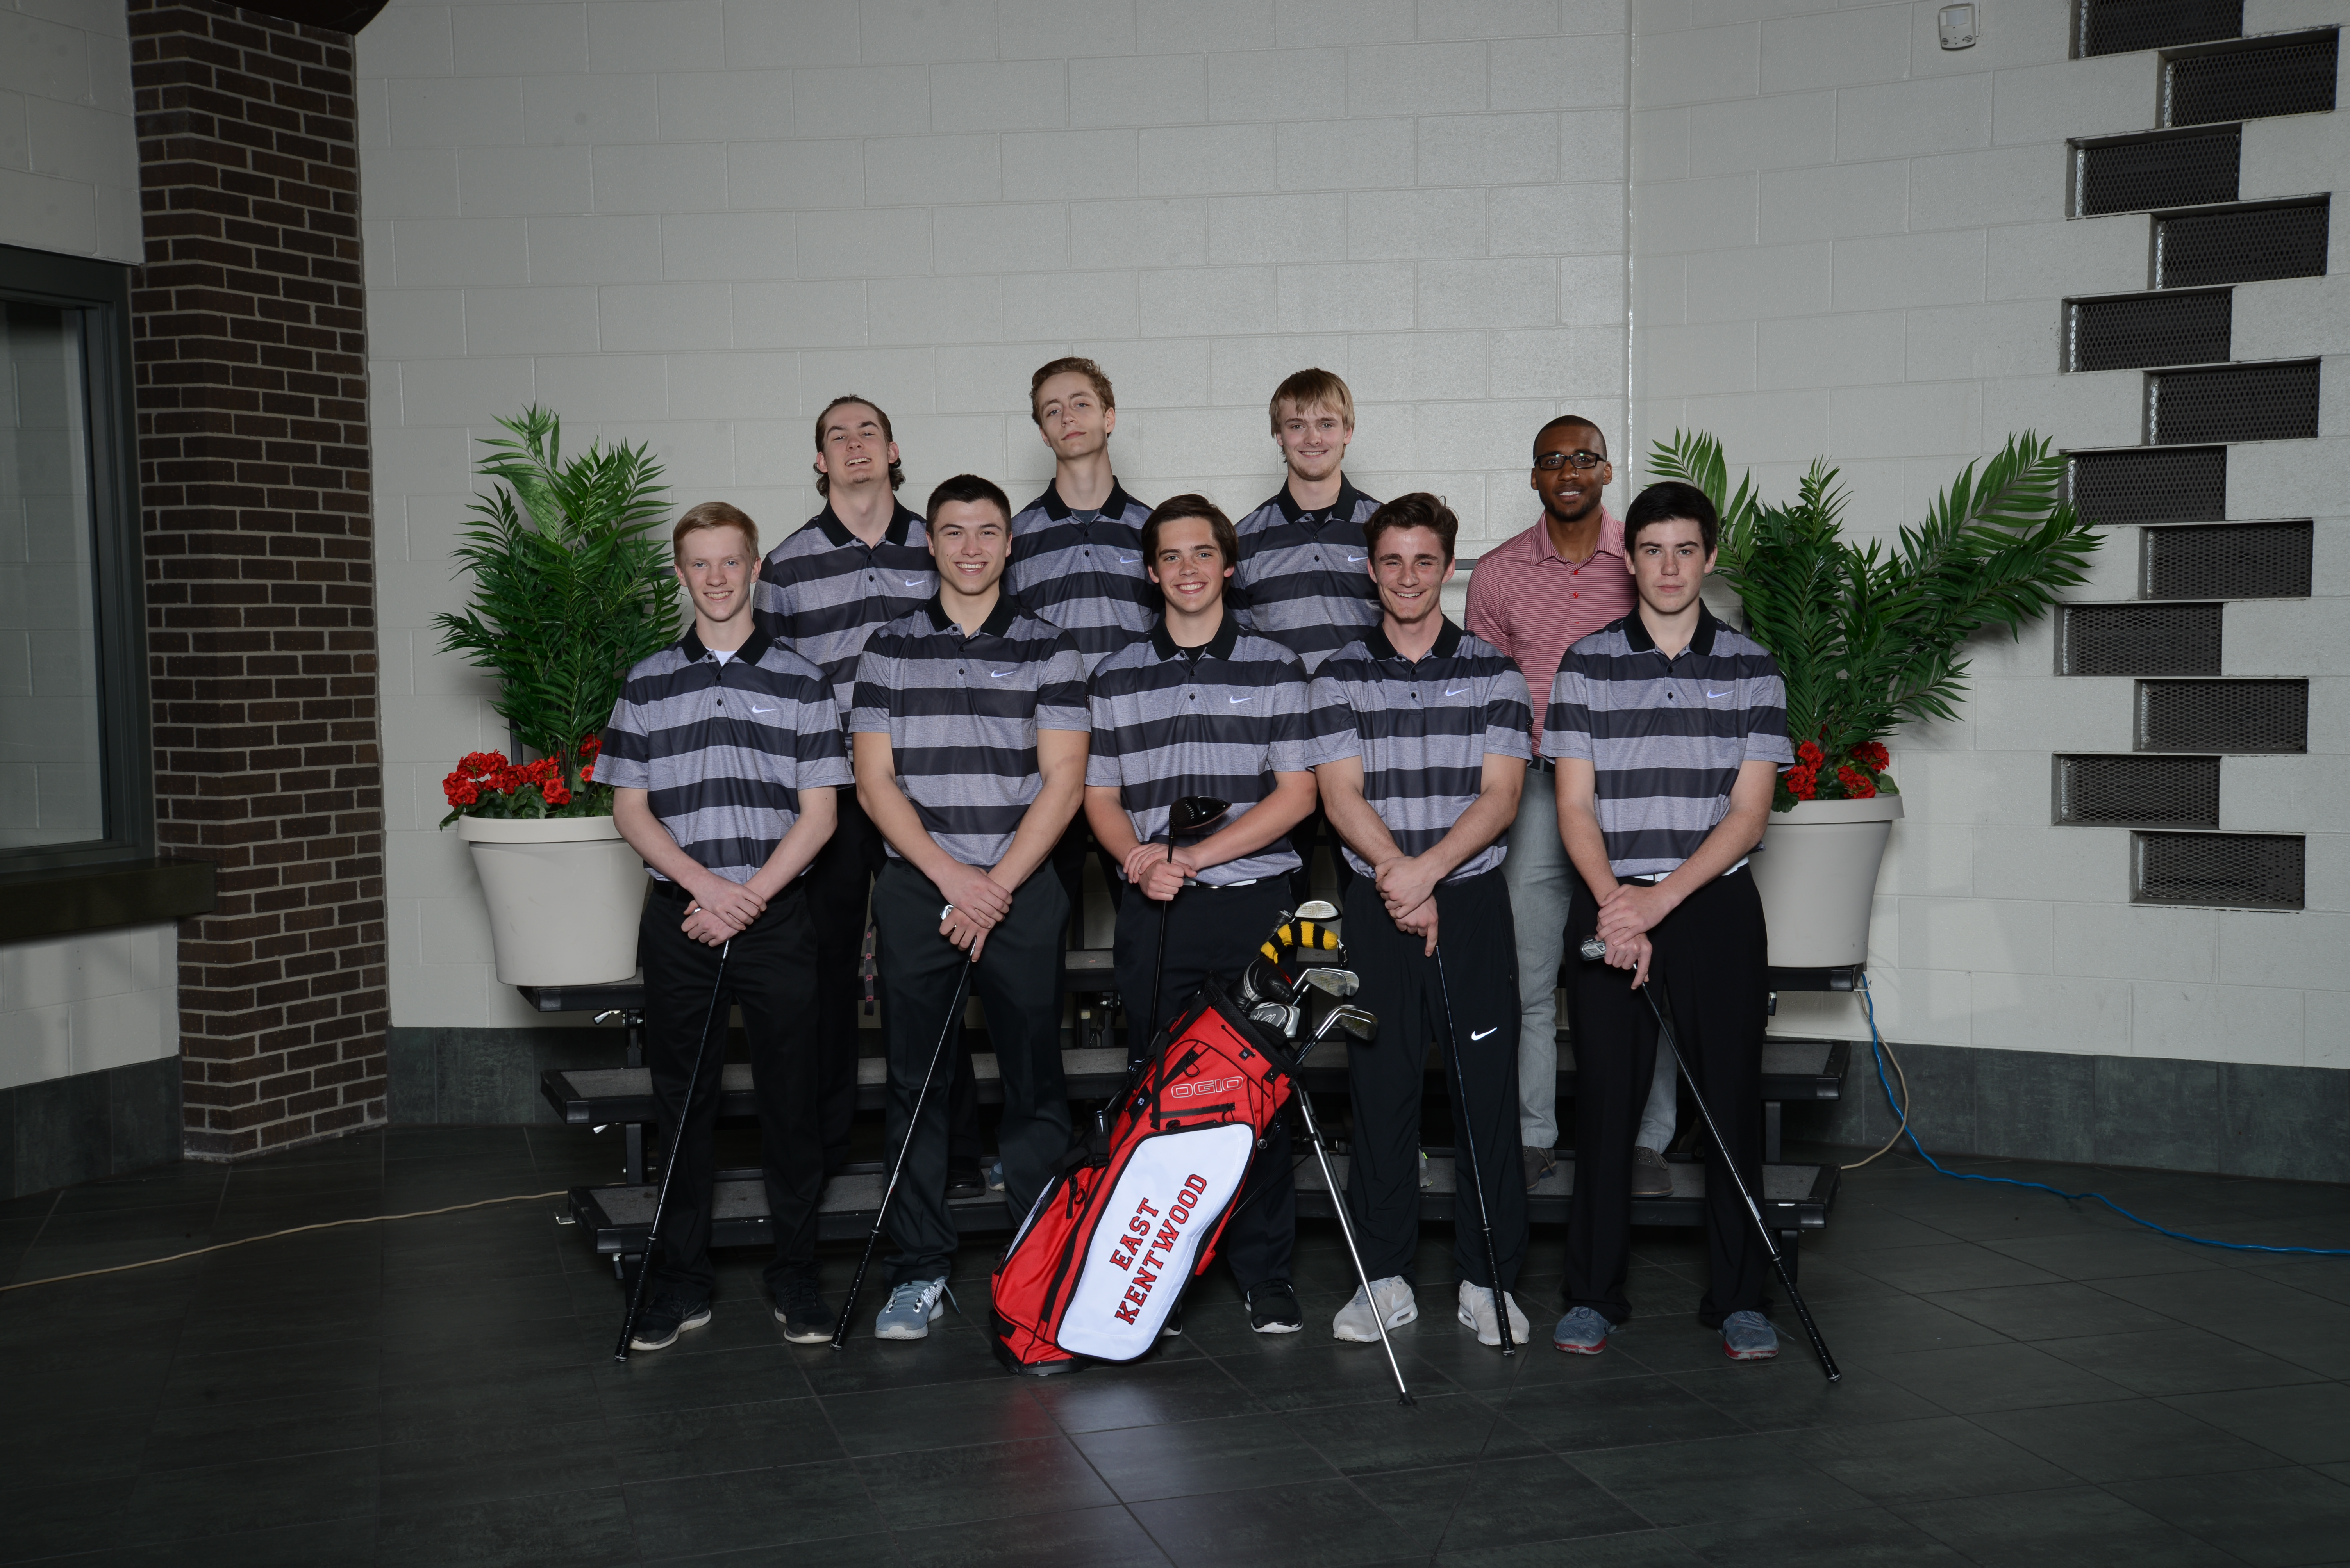
Click here for schedule.
EAST KENTWOOD JV BOYS GOLF 2016
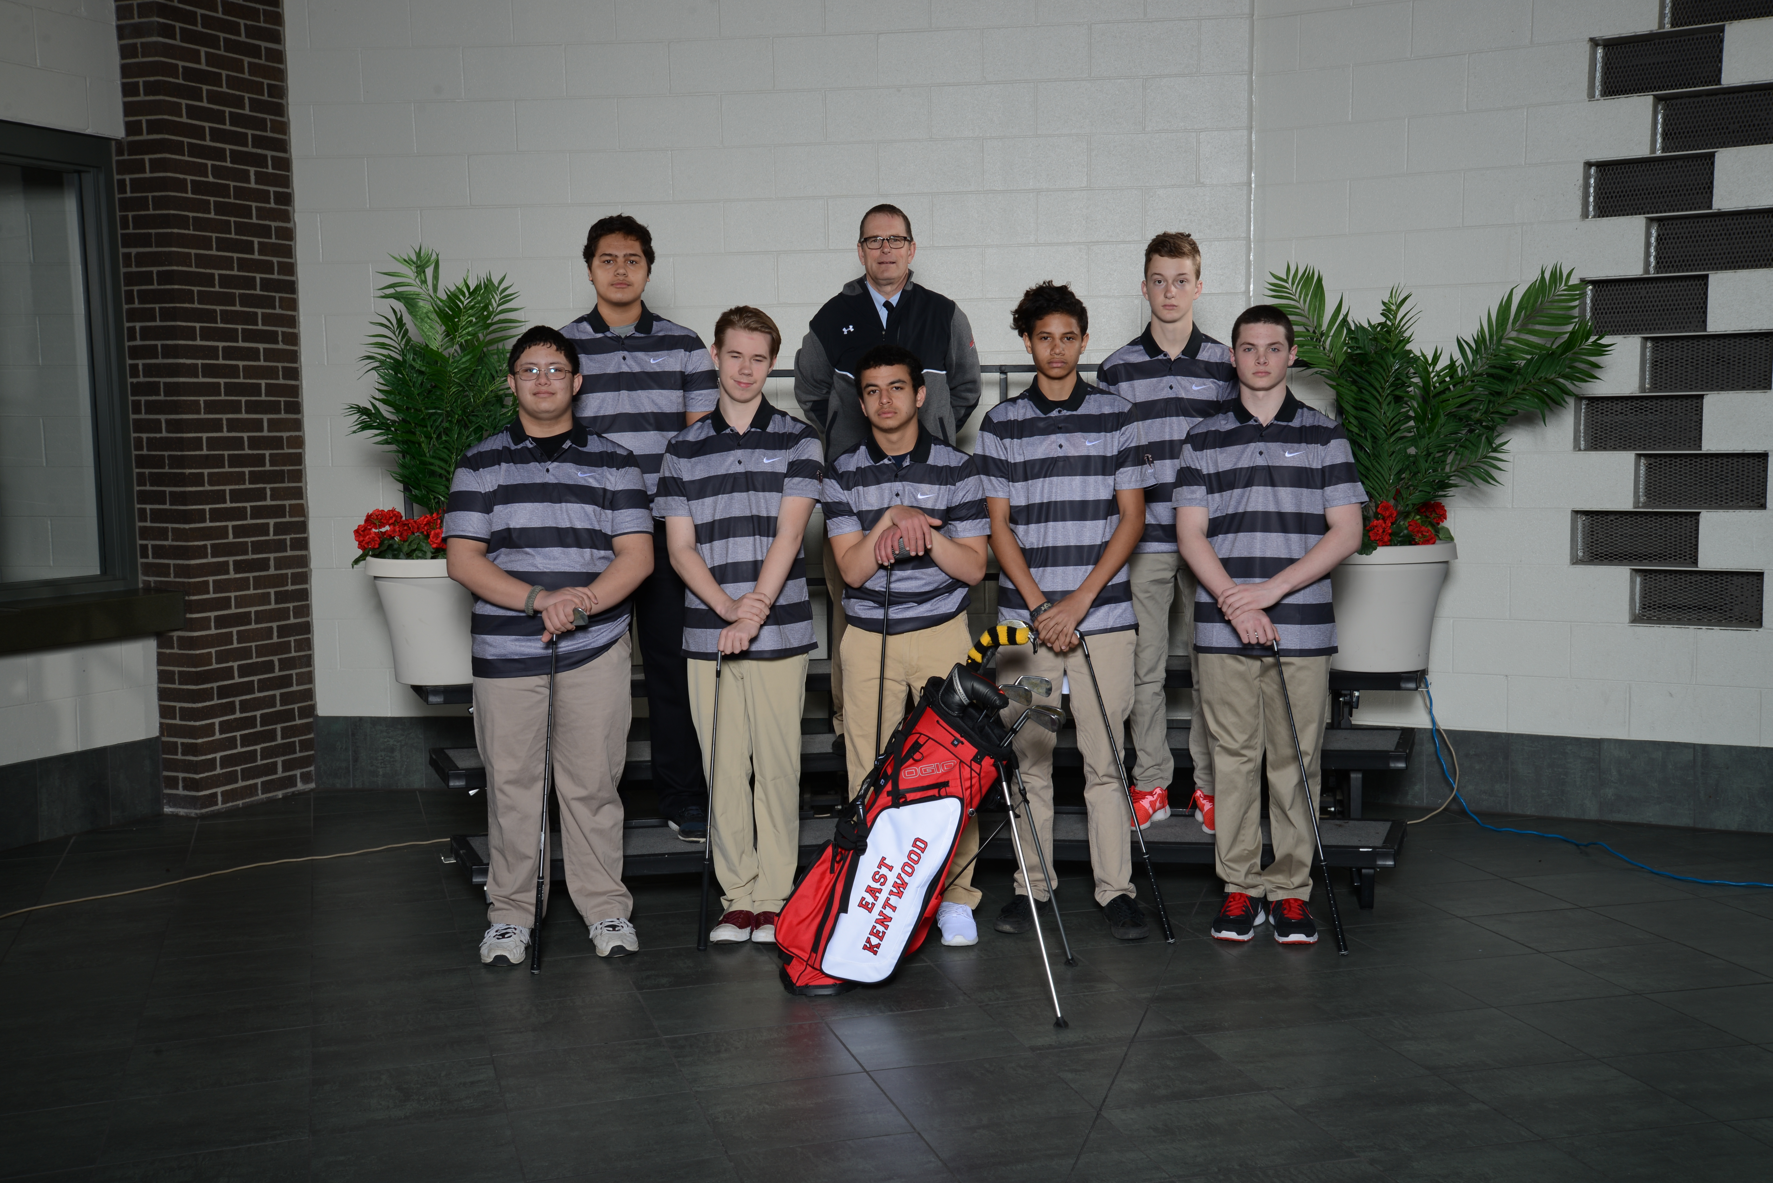
Click here for schedule.

