2015-2016 Boys Varsity Soccer

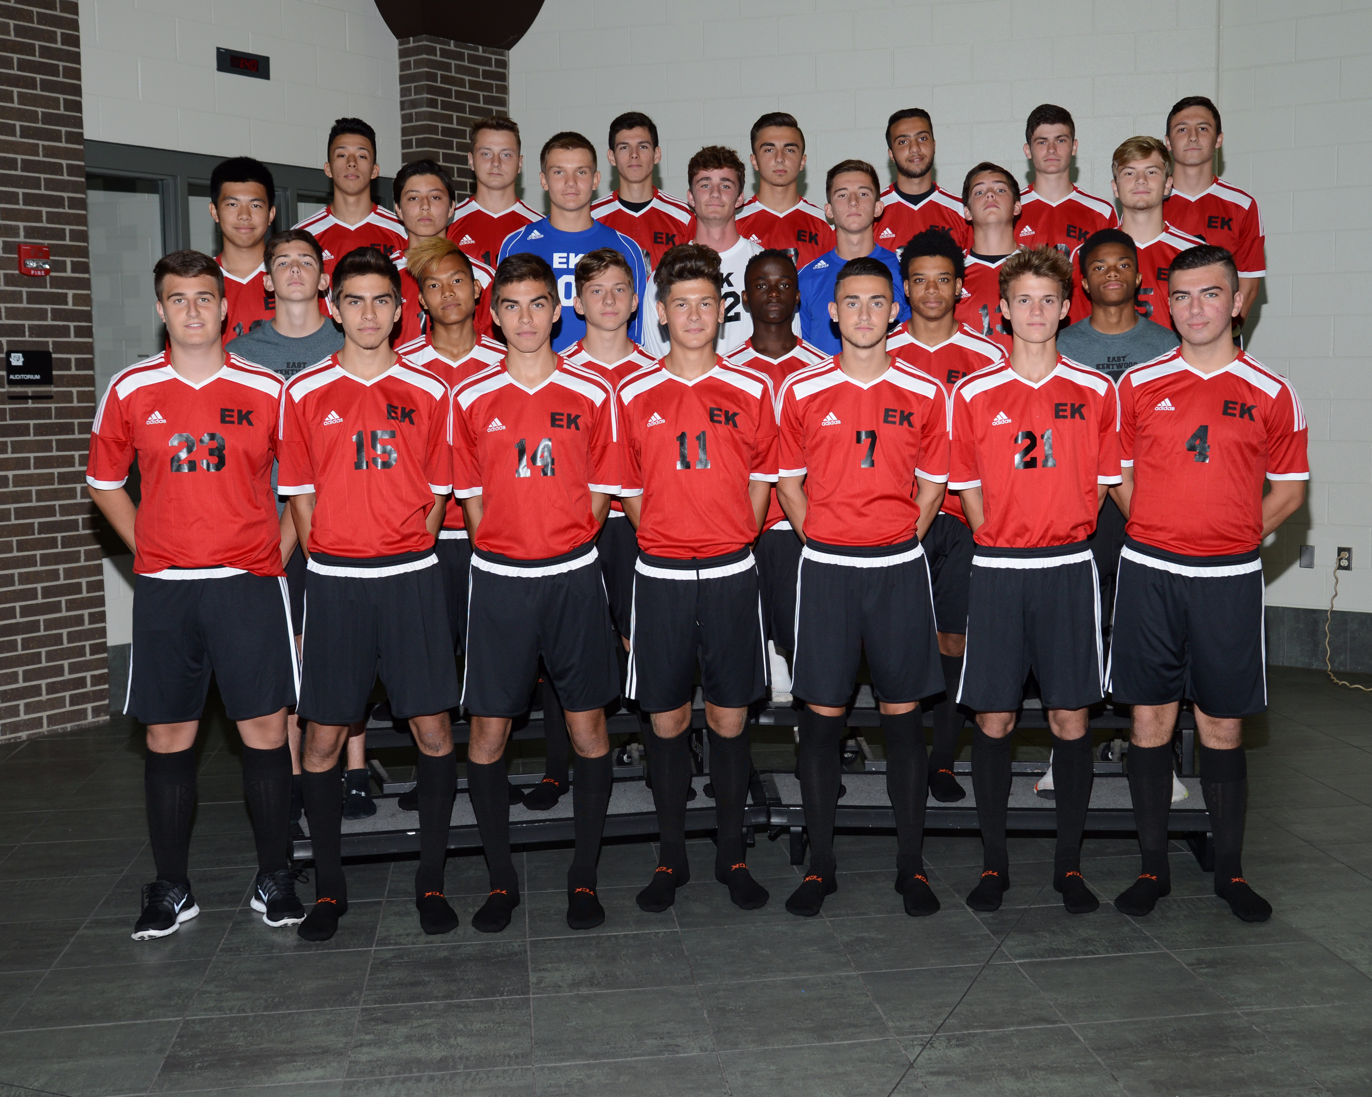

Click here for schedule

2015-2016 J.V. Boys Soccer

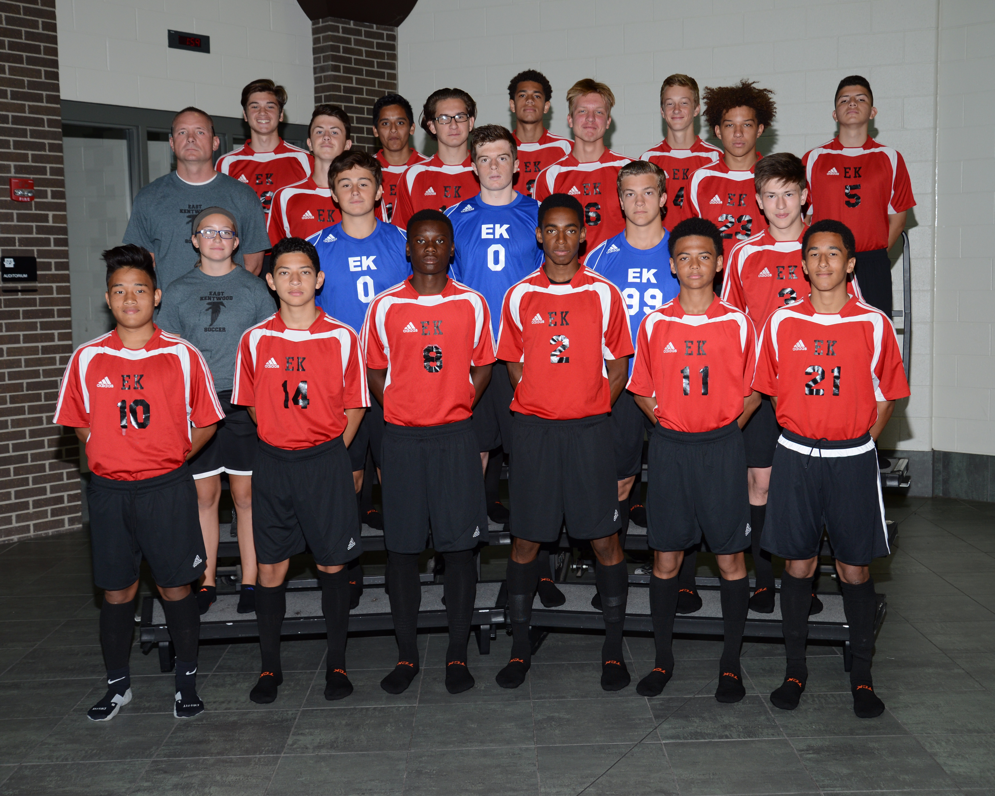

Click here for schedule

2015-2016 Freshman Boys Soccer

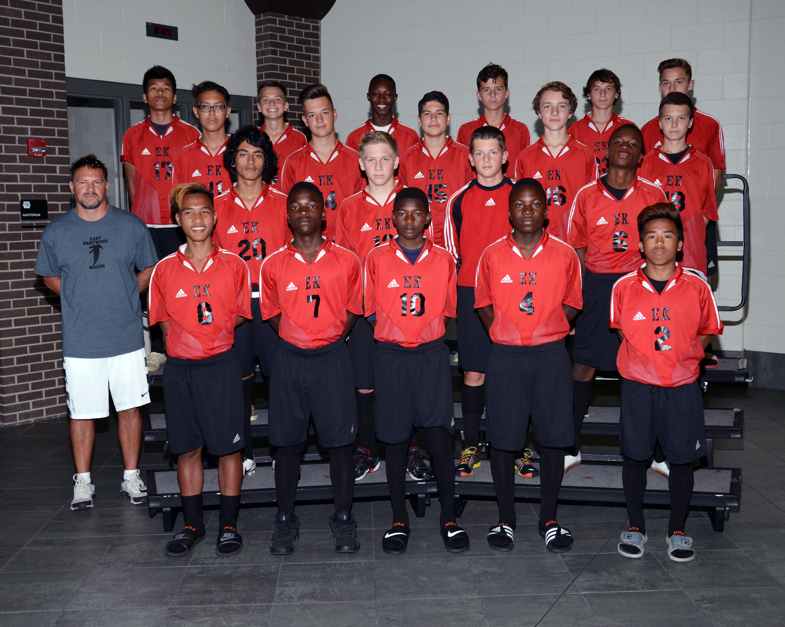
Click here for schedule

