EAST KENTWOOD BOY’S VARSITY BOWLING 2015-16

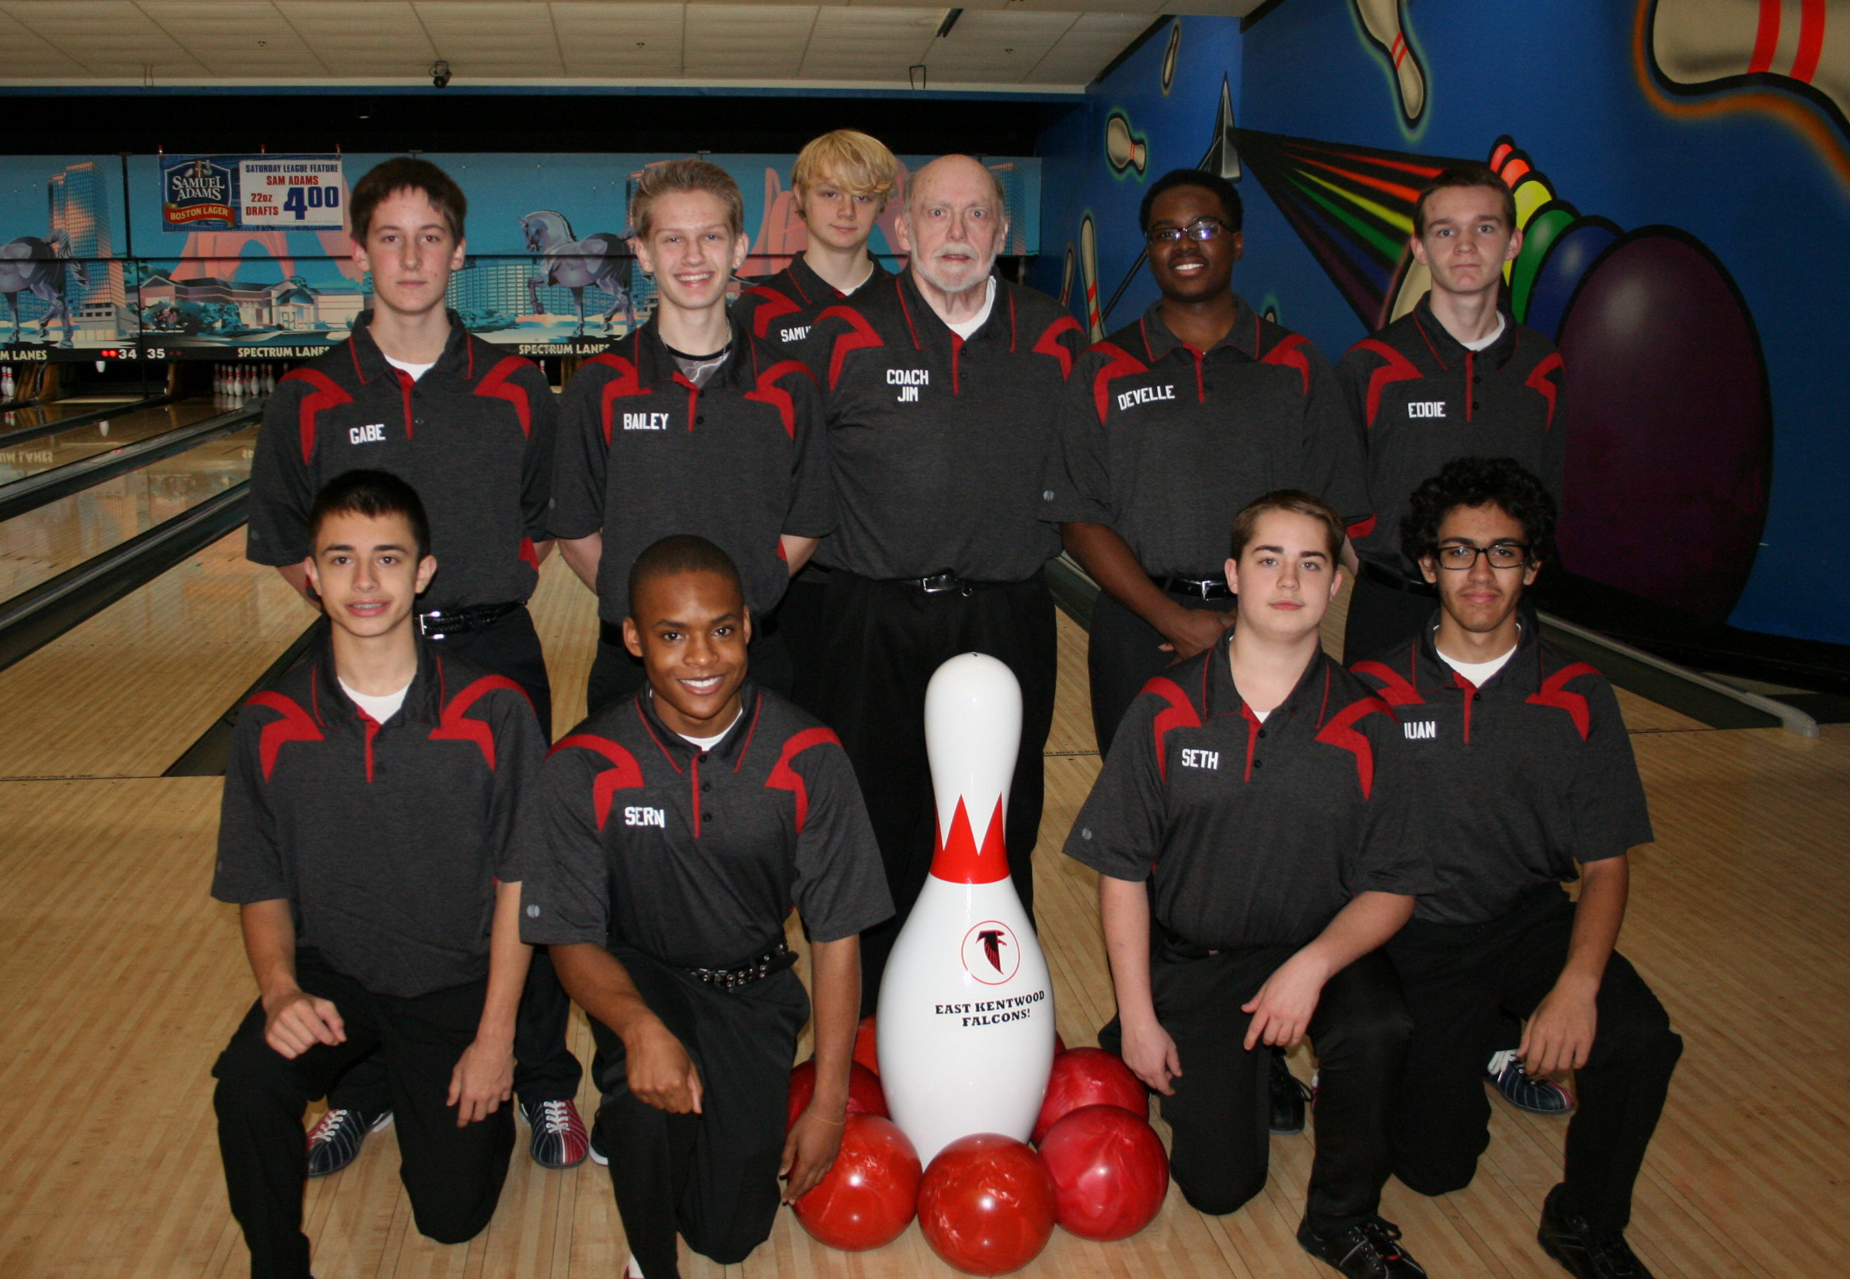

Click here for schedule

EAST KENTWOOD GIRLS VARSITY BOWLING 2015-16

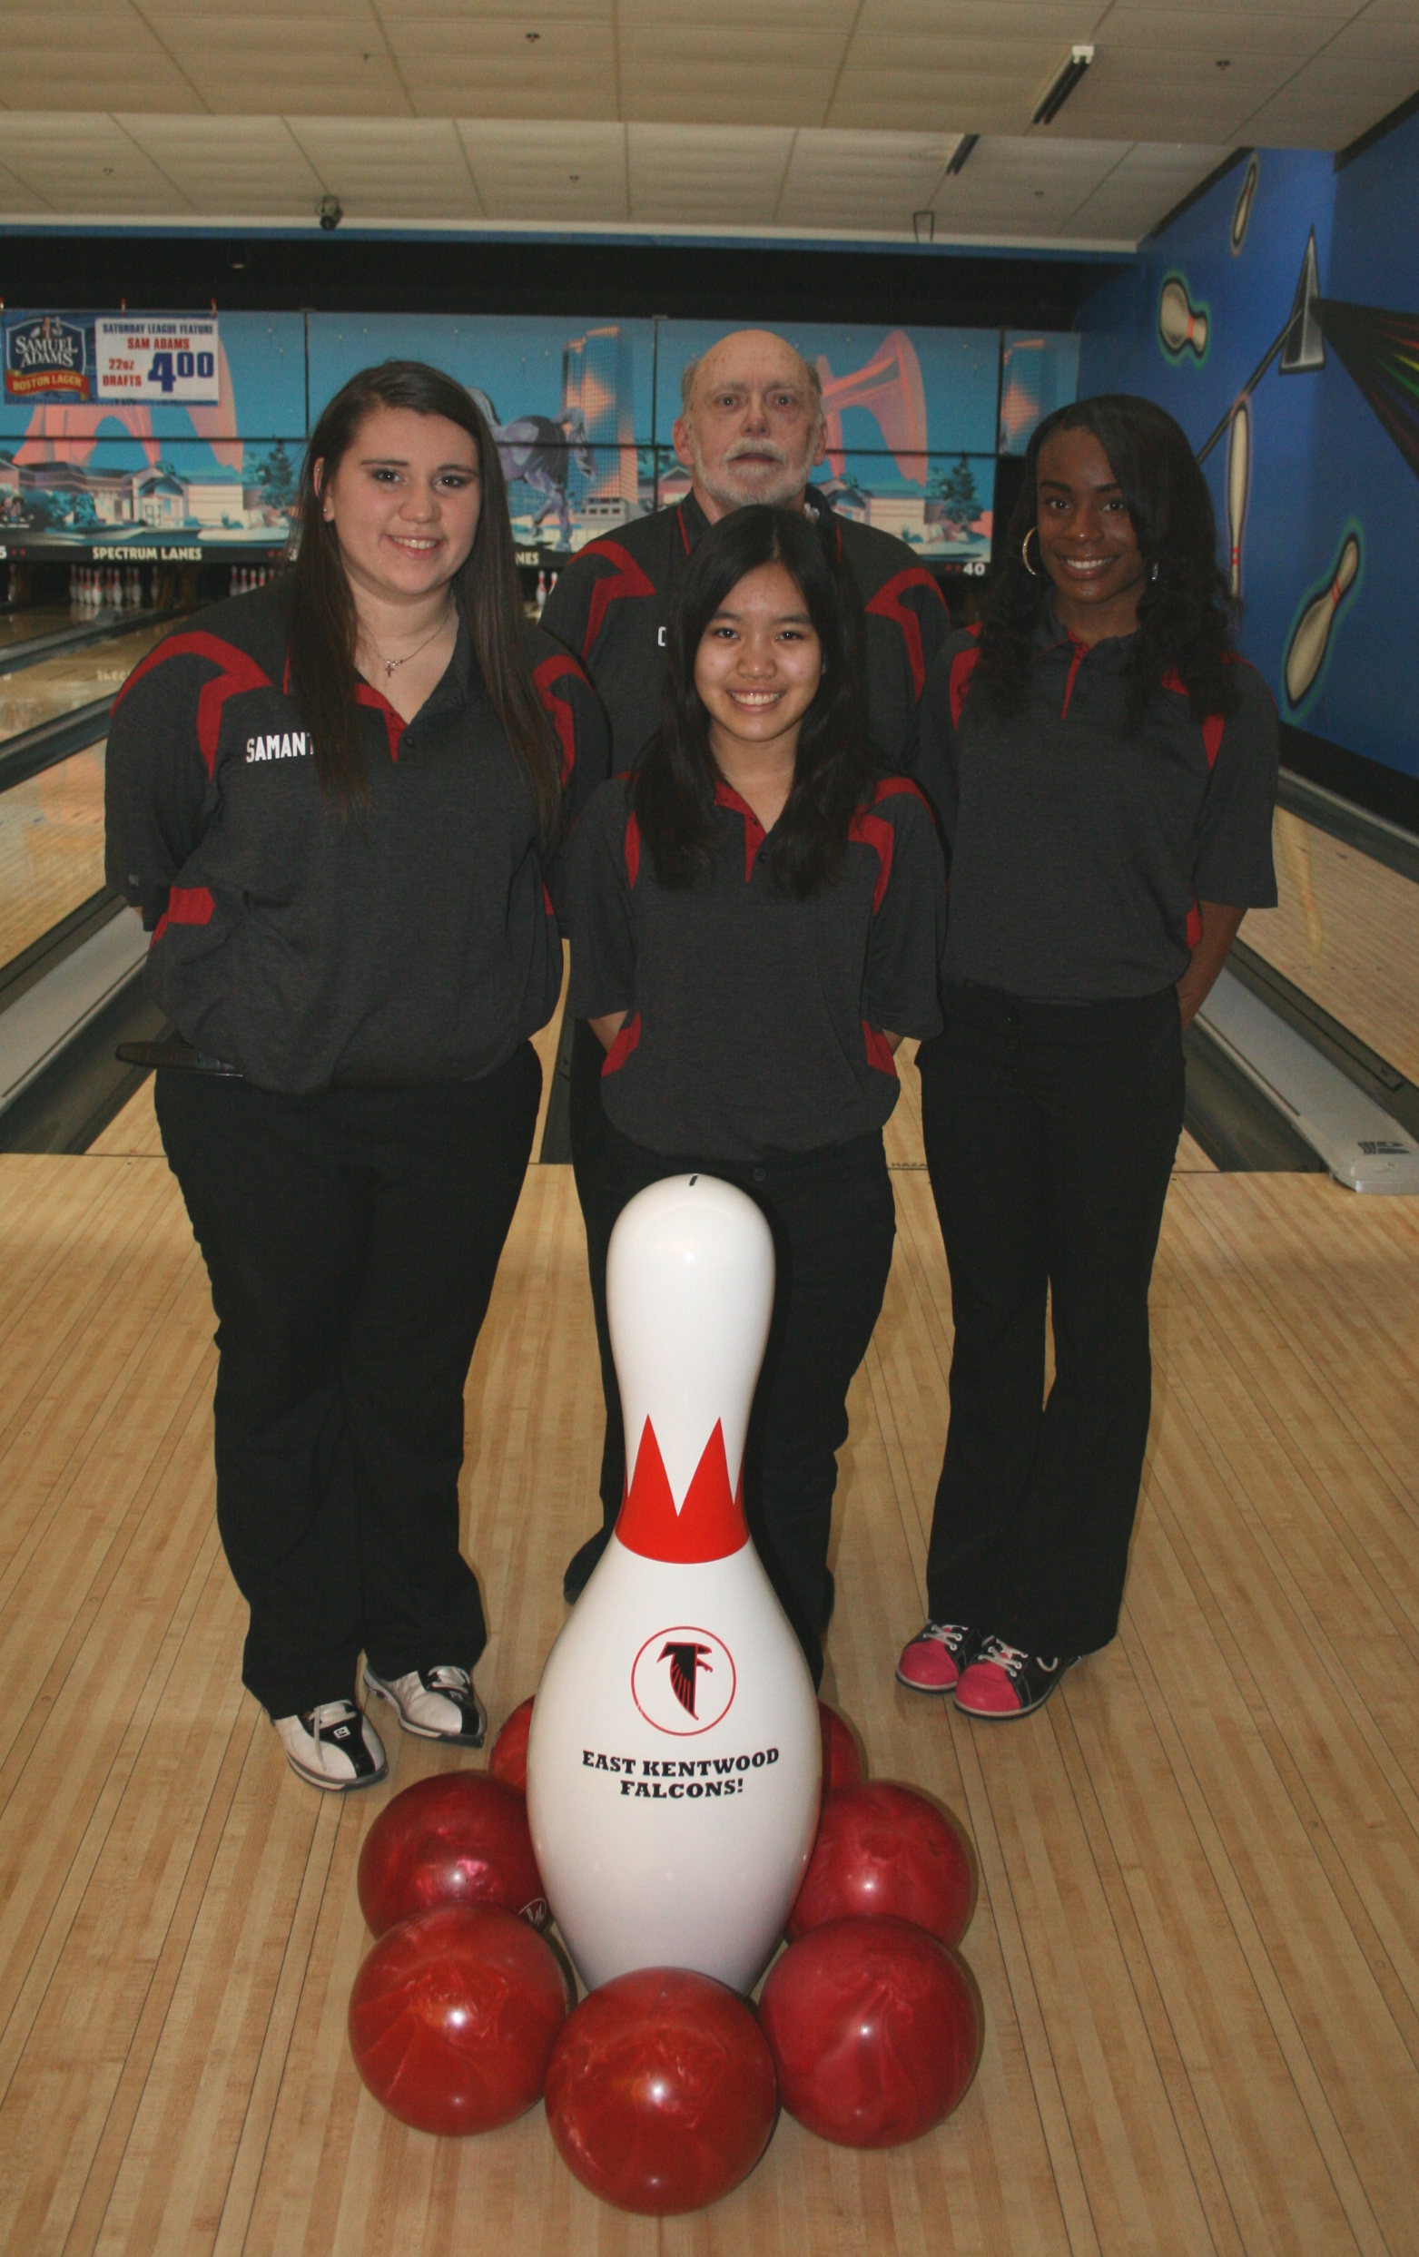

Click here for schedule

