EAST KENTWOOD VARSITY BASEBALL 2016
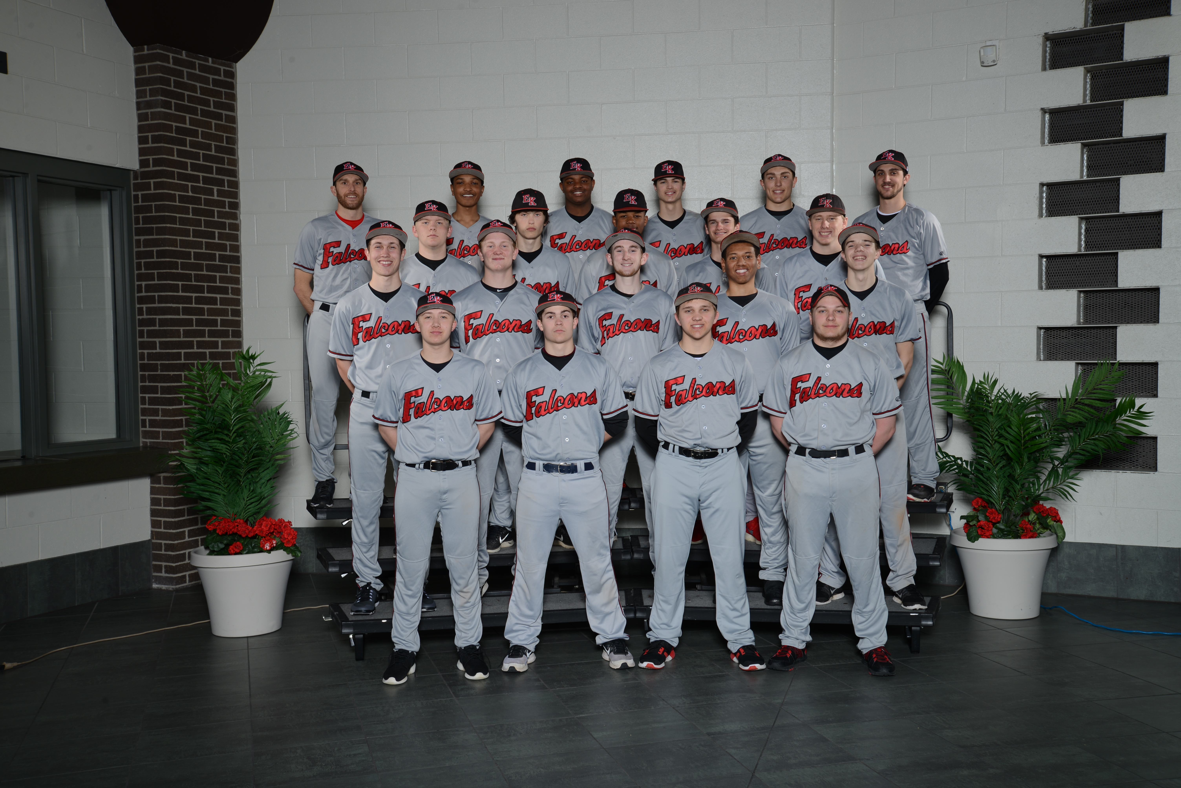
Click for Schedule

EAST KENTWOOD J.V. BASEBALL 2016
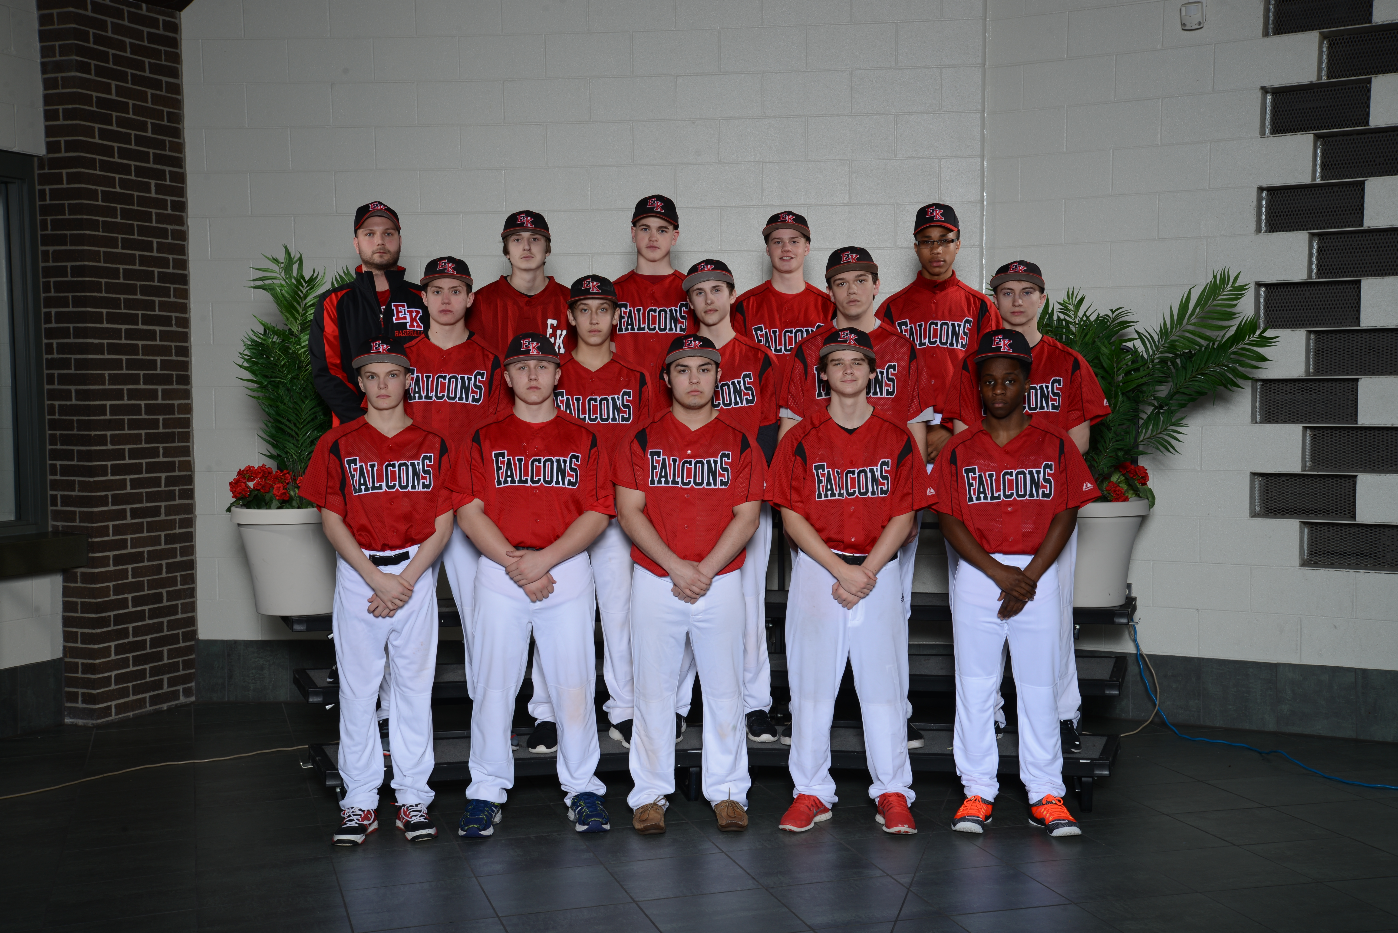
Click here for Schedule

EAST KENTWOOD FRESHMAN BASEBALL 2016
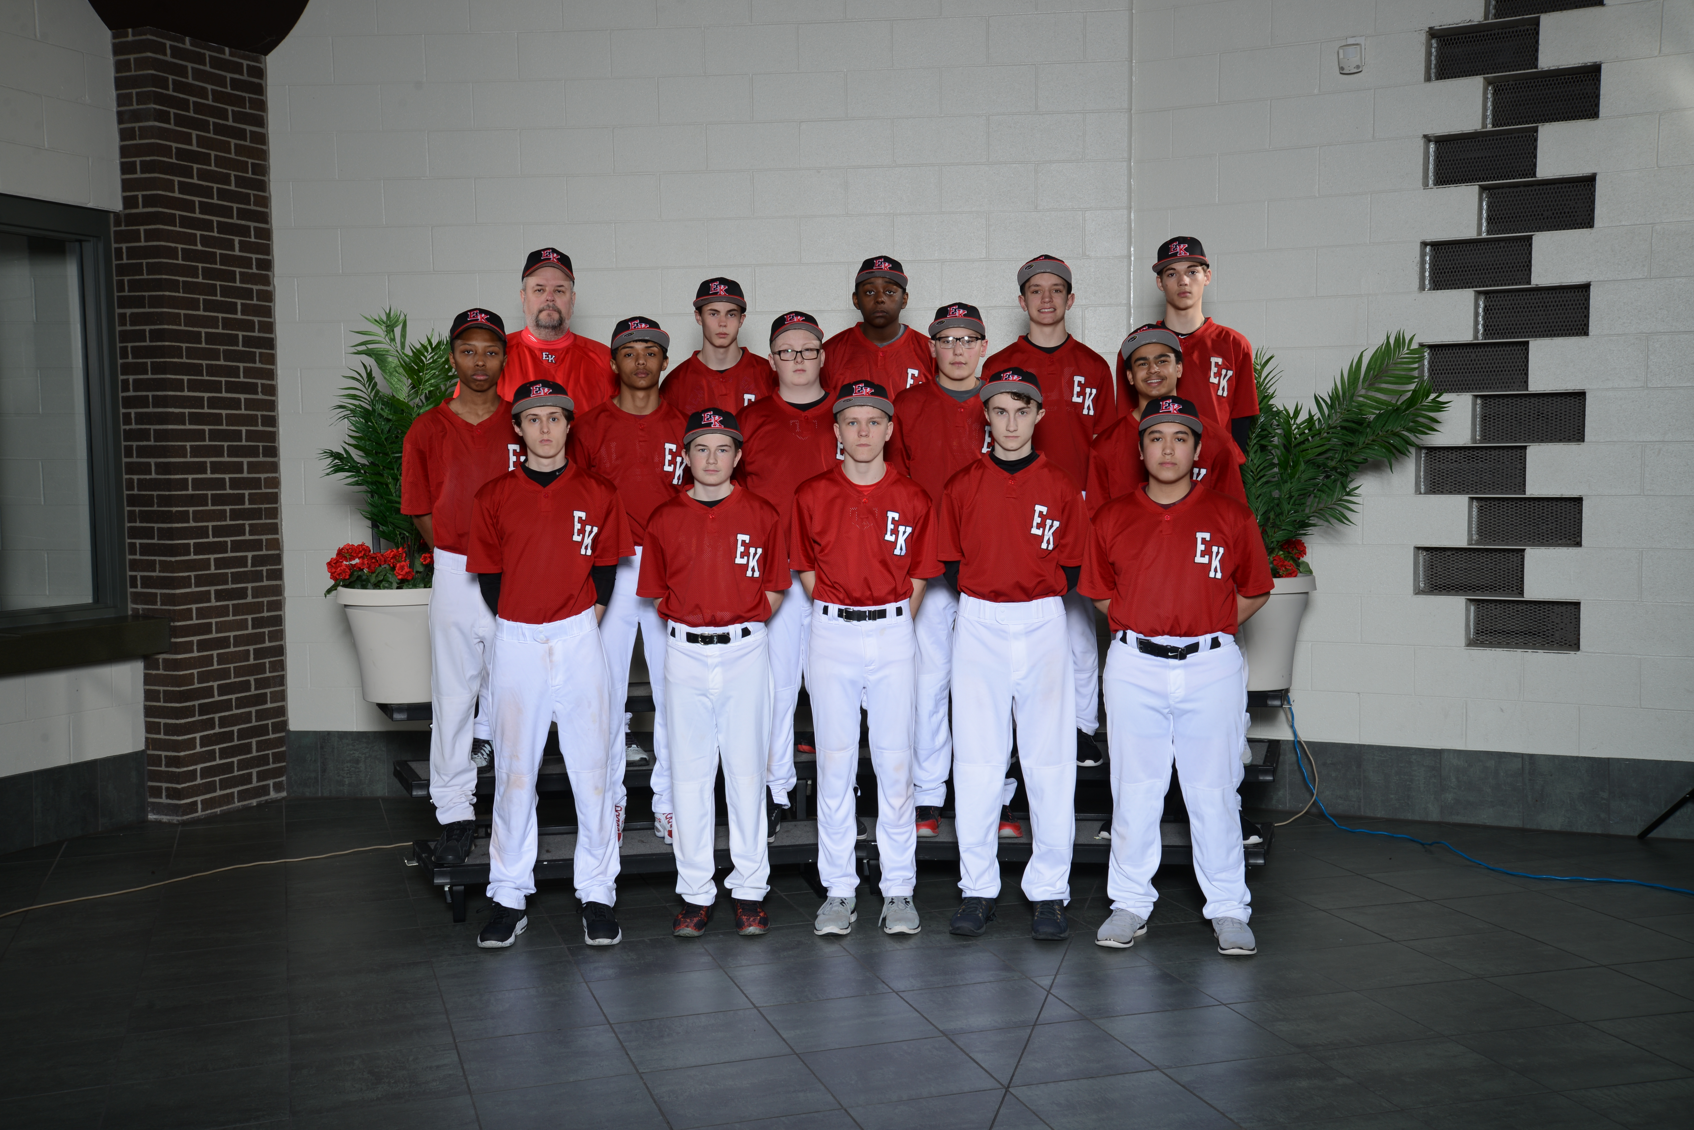
Click here for schedule

