2015-2016
Boys Varsity Tennis

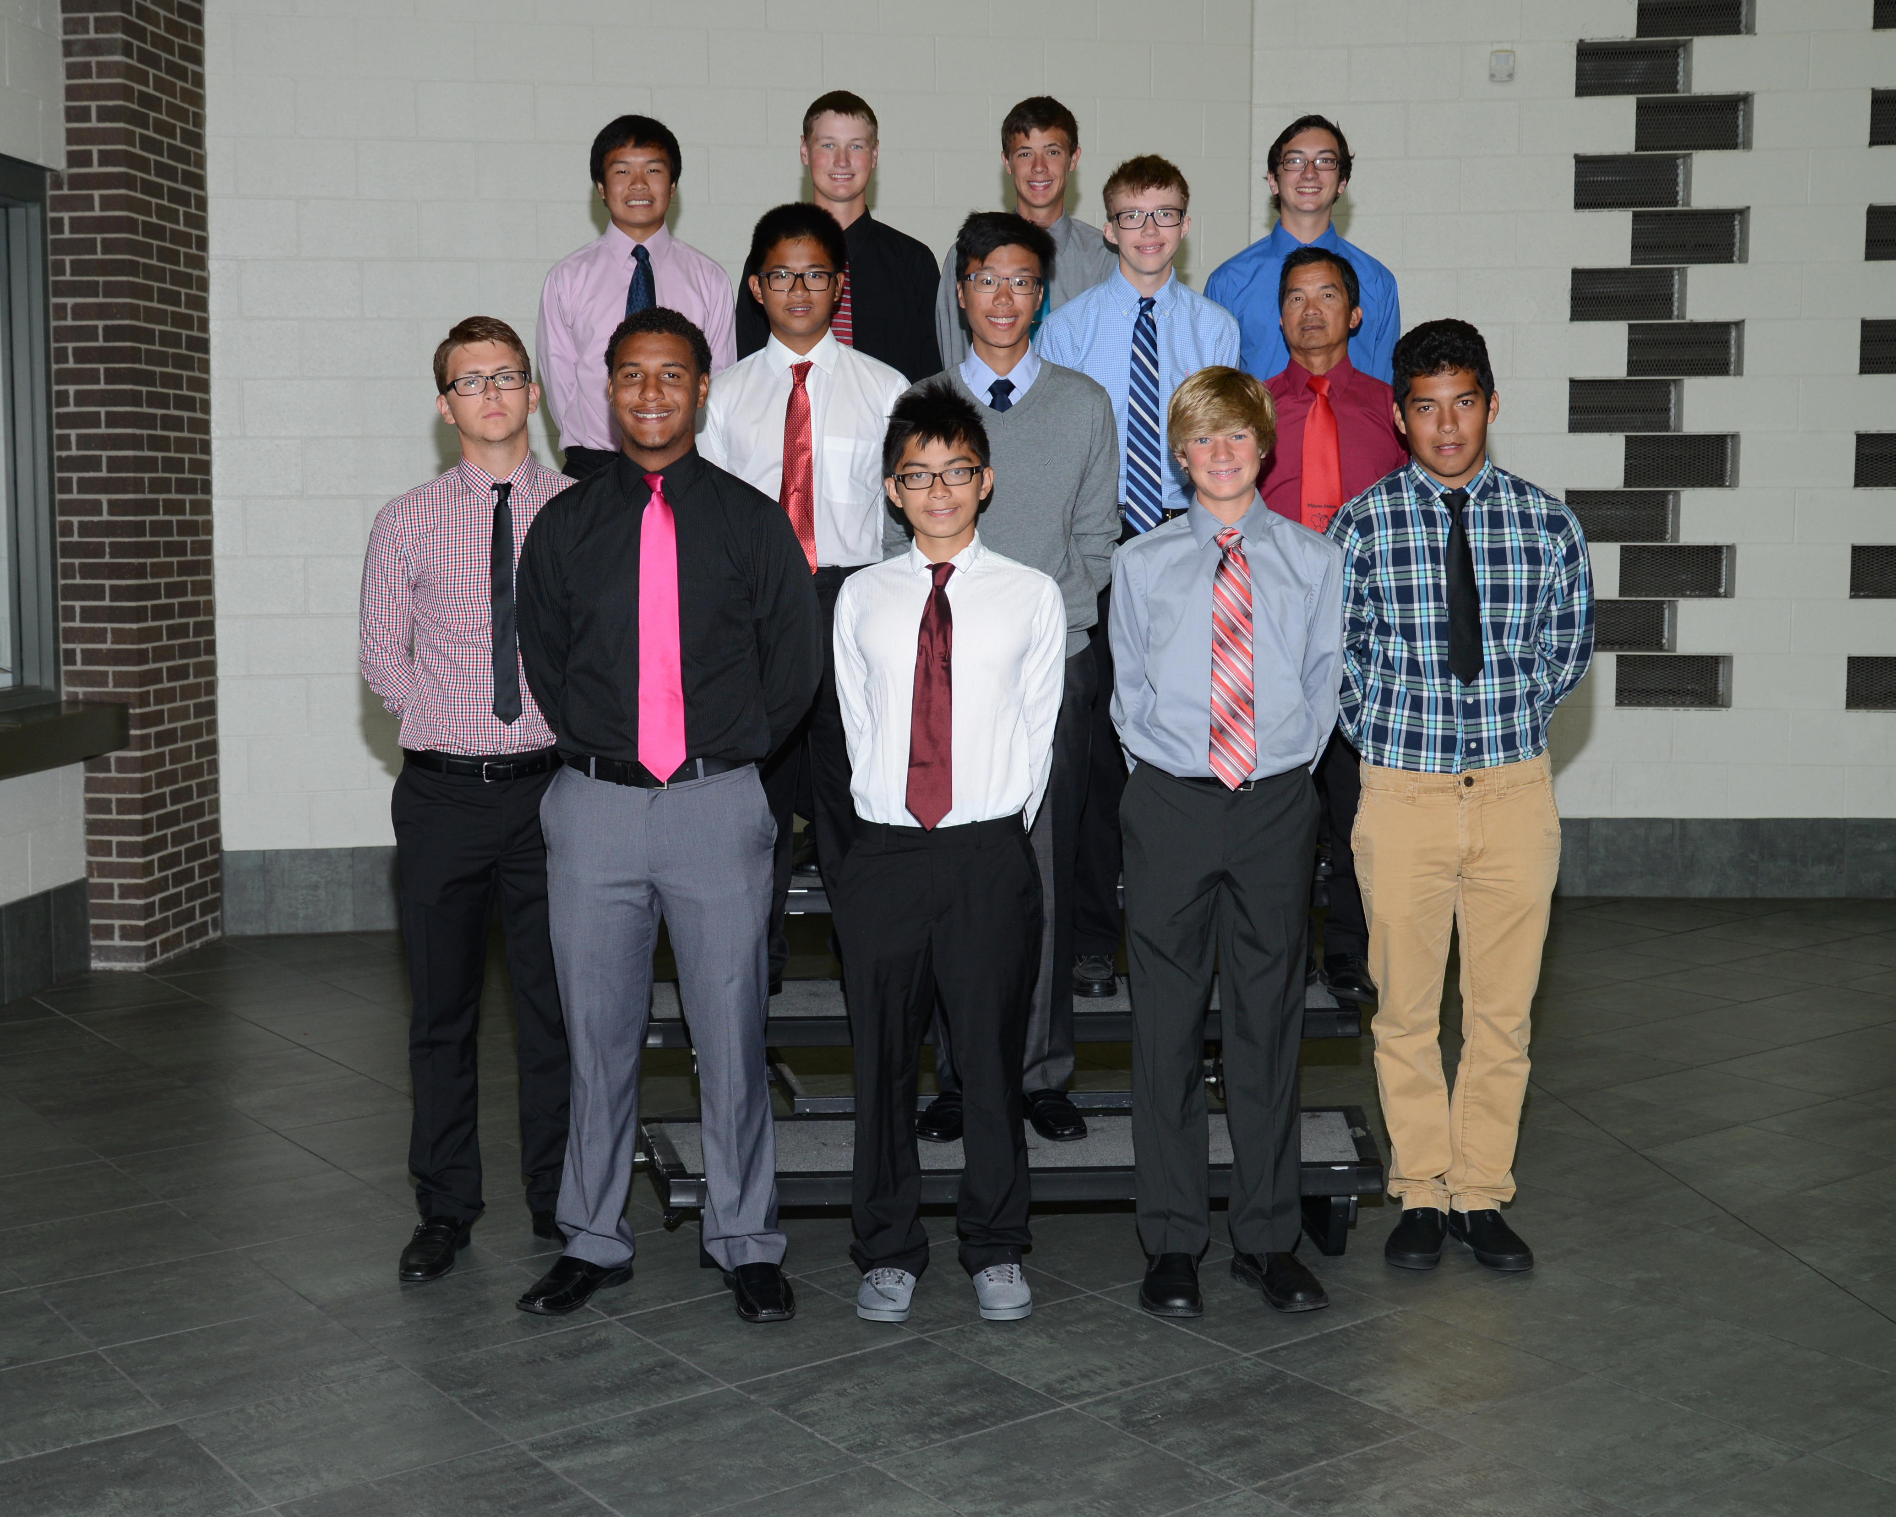

Click here for schedule
2015-2016
Boys J.V. Tennis

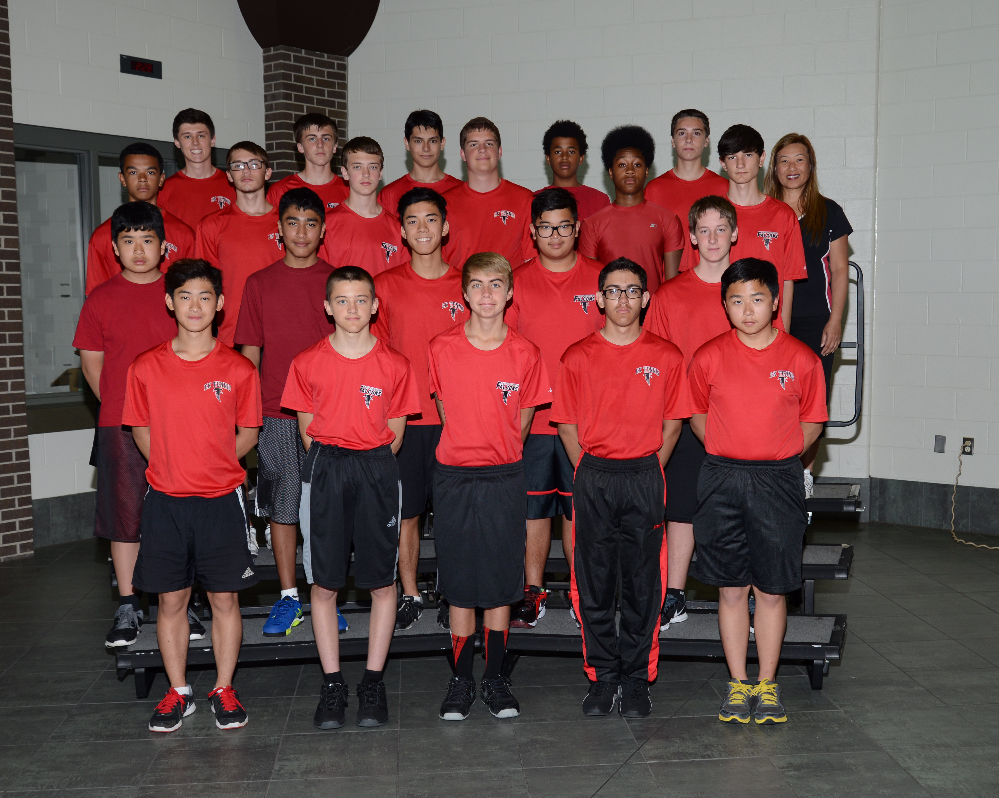
Click here for schedule

